**Database Connectivity in asp.net**

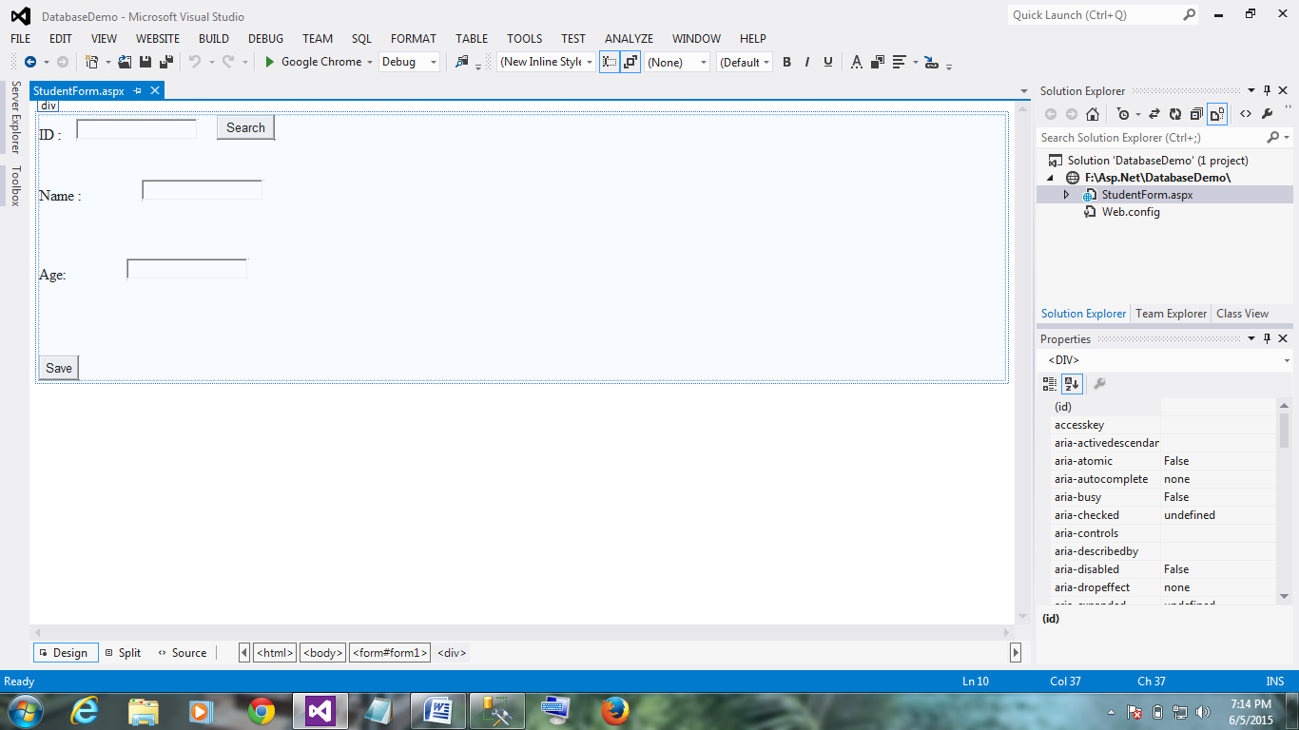

In<%@ Page Language="C#" AutoEventWireup="true" CodeFile="StudentForm.aspx.cs" herits="StudentForm" %>

<!DOCTYPE html>

<html xmlns="http://www.w3.org/1999/xhtml">

<head runat="server">

<title></title>

</head>

<body>

<form id="form1" runat="server">

<div>

ID :&nbsp;&nbsp;&nbsp;

<asp:TextBox ID="TextBox1" runat="server"></asp:TextBox>

&nbsp;&nbsp;&nbsp;&nbsp;

<asp:Button ID="btnSearch" runat="server" OnClick="btnSearch_Click" Text="Search" />

<br />

<br />

<br />

Name :&nbsp;&nbsp;&nbsp;&nbsp;&nbsp;&nbsp;&nbsp;&nbsp;&nbsp;&nbsp;&nbsp;&nbsp;&nbsp;&nbsp;&nbsp;

<asp:TextBox ID="TextBox2" runat="server"></asp:TextBox>

<br />

<br />

<br />

<br />

Age:&nbsp;&nbsp;&nbsp;&nbsp;&nbsp;&nbsp;&nbsp;&nbsp;&nbsp;&nbsp;&nbsp;&nbsp;&nbsp;&nbsp;&nbsp;

<asp:TextBox ID="TextBox3" runat="server"></asp:TextBox>

<br />

<br />

<br />

<br />

<br />

<asp:Button ID="Button1" runat="server" OnClick="Button1_Click" Text="Save" />

</div>

</form>

</body>

</html>

using System;

using System.Collections.Generic;

using System.Linq;

using System.Web;

using System.Web.UI;

using System.Web.UI.WebControls;

using System.Data.SqlClient;

public partial class StudentForm : System.Web.UI.Page

{

protected void Page_Load(object sender, EventArgs e)

{

}

protected void Button1_Click(object sender, EventArgs e)

{

SqlConnection con = new SqlConnection();

con.ConnectionString = "Data Source=(local);Initial Catalog=Lavania;Integrated Security=true";

con.Open();

SqlCommand cmd = new SqlCommand("insert into student values(@a,@b,@c)",con);

int id=Convert.ToInt32(TextBox1.Text);

string name = TextBox2.Text;

int age =Convert.ToInt32( TextBox3.Text);

cmd.Parameters.Add(new SqlParameter("@a",id));

cmd.Parameters.Add(new SqlParameter("@b", name));

cmd.Parameters.Add(new SqlParameter("@c", age));

cmd.ExecuteNonQuery();

con.Close();

}

protected void btnSearch_Click(object sender, EventArgs e)

{

SqlConnection con = new SqlConnection();

con.ConnectionString = "Data Source=(local);Initial Catalog=Lavania;Integrated Security=true";

con.Open();

SqlCommand cmd = new SqlCommand("select * from student where id=@a", con);

int id = Convert.ToInt32(TextBox1.Text);

cmd.Parameters.Add(new SqlParameter("@a", id));

SqlDataReader r = cmd.ExecuteReader();

r.Read();

TextBox1.Text = r.GetValue(0).ToString();

TextBox2.Text = r.GetString(1);

TextBox3.Text = r.GetValue(2).ToString();

con.Close();

}

}

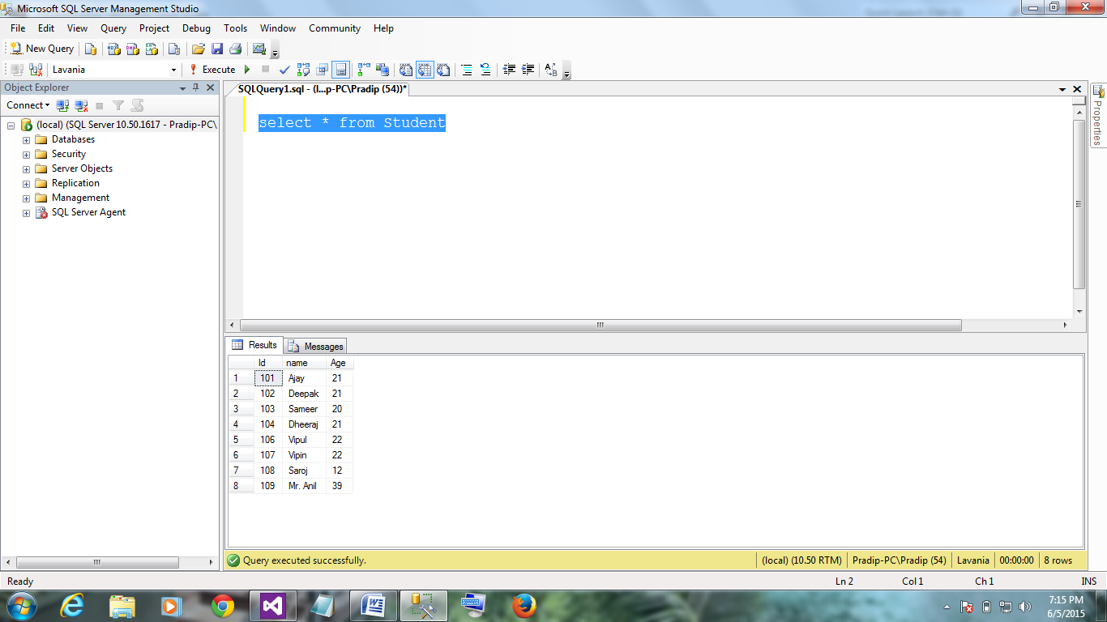

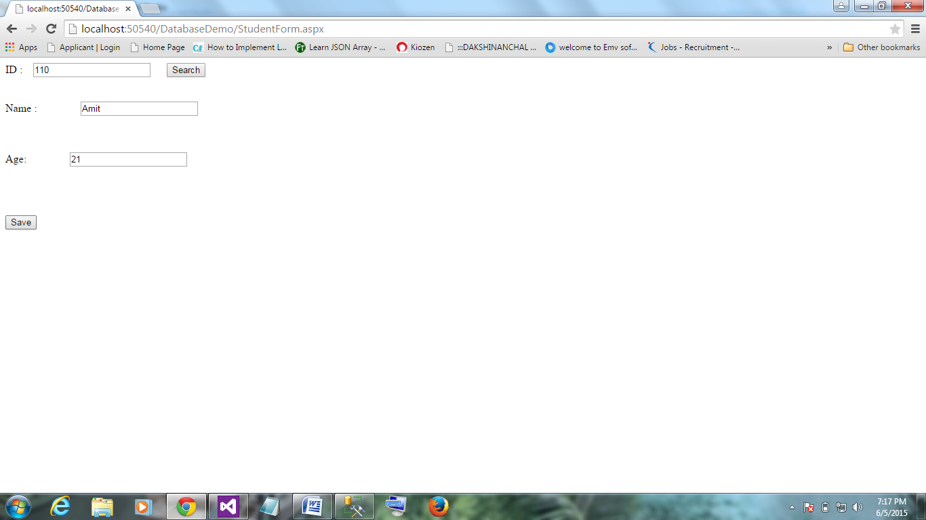

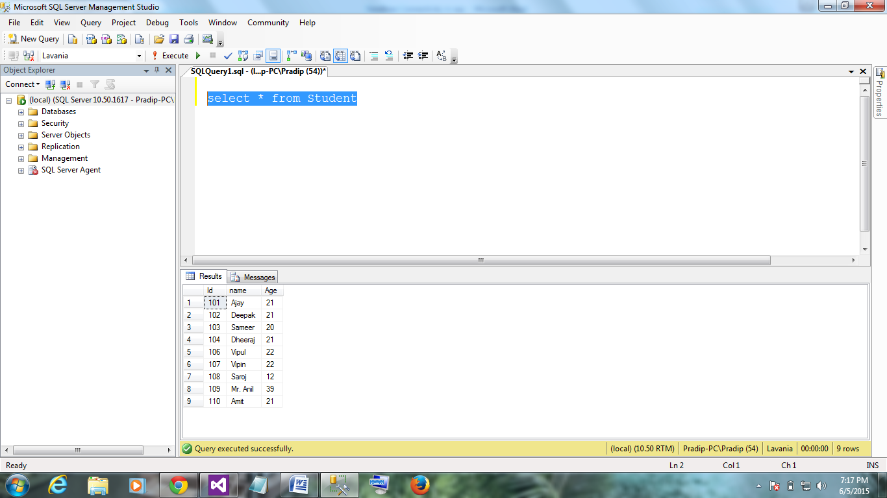

GridViewIn asp.net

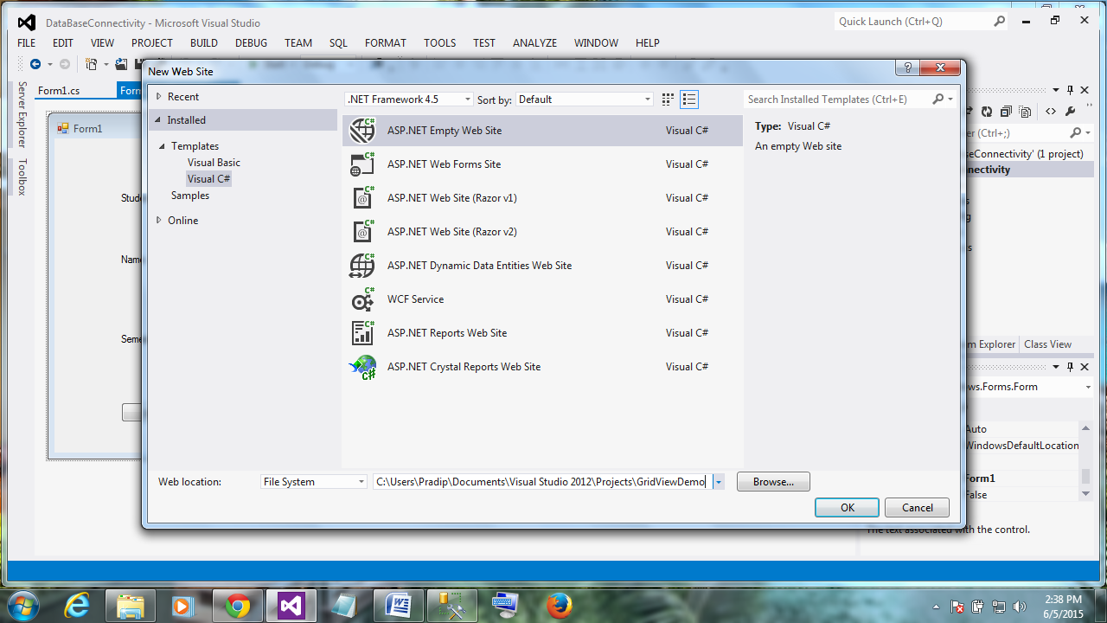

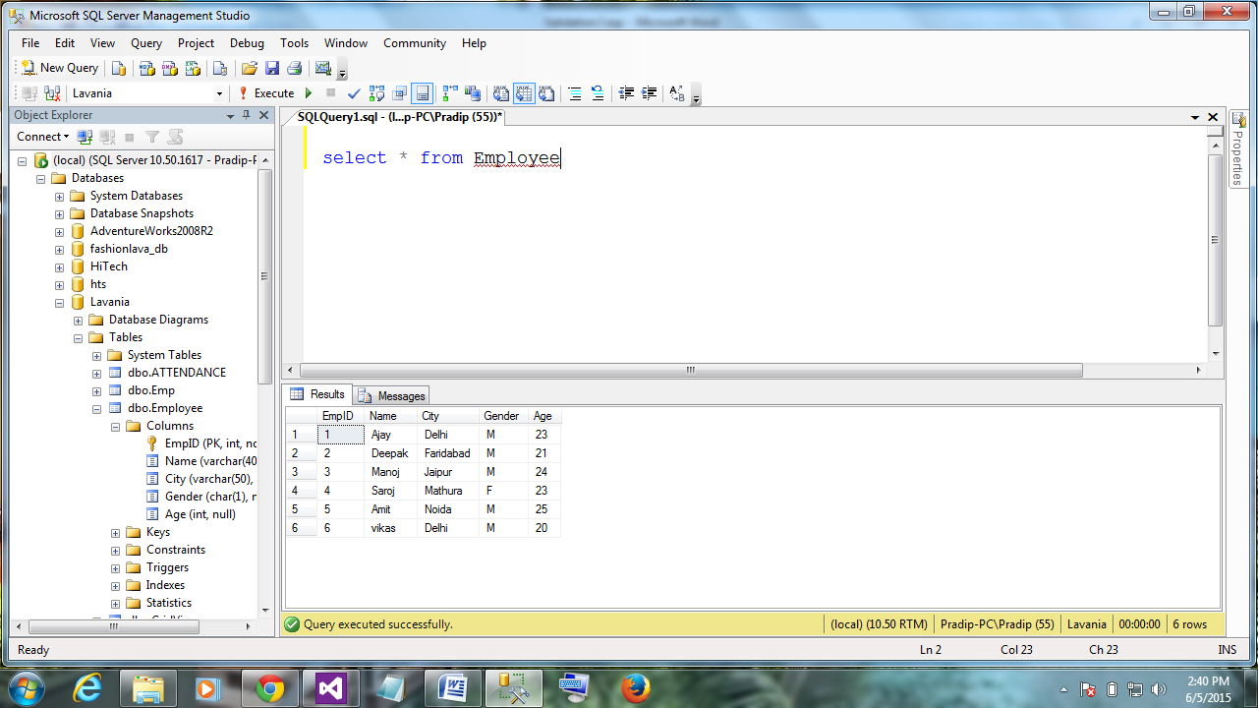

Add apage and add a gridView control on that

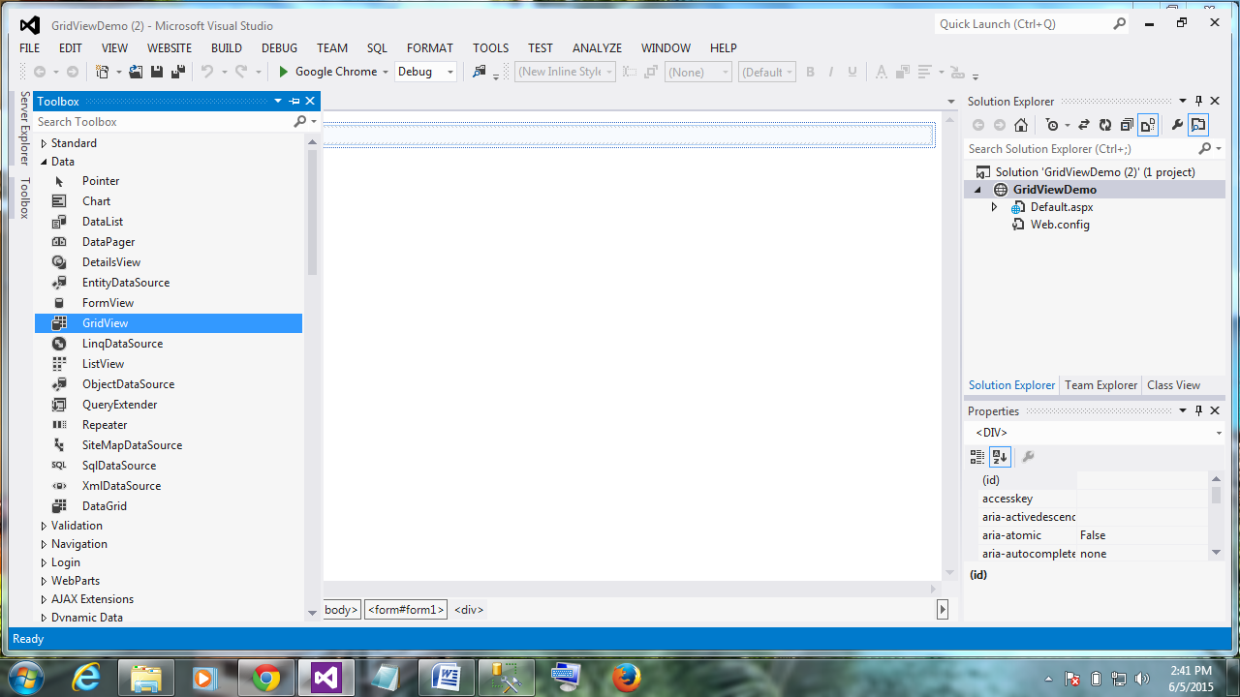

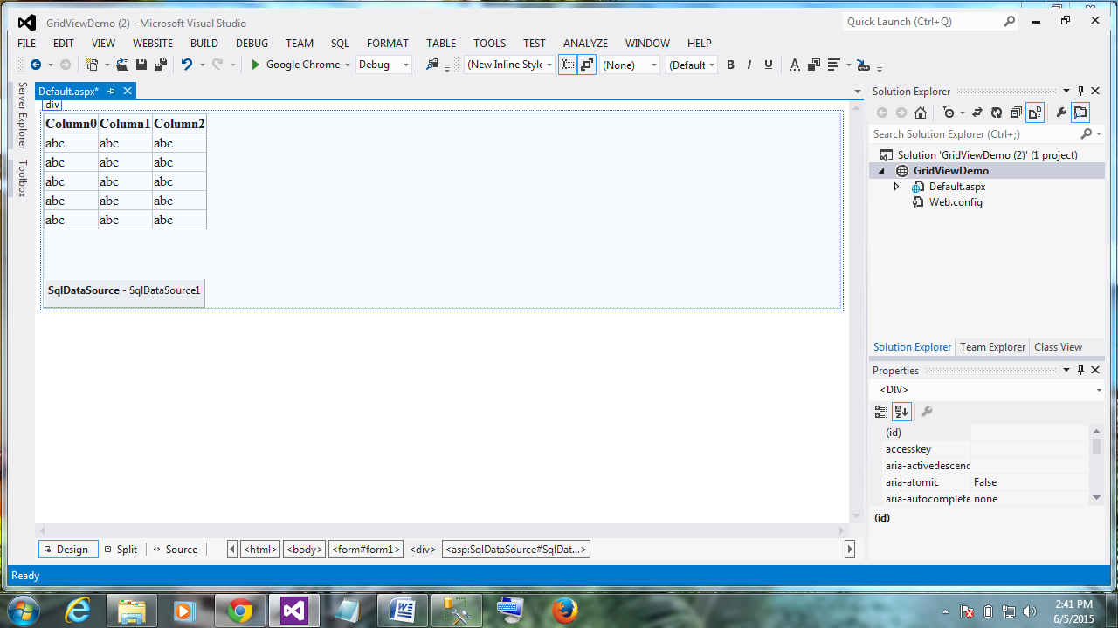

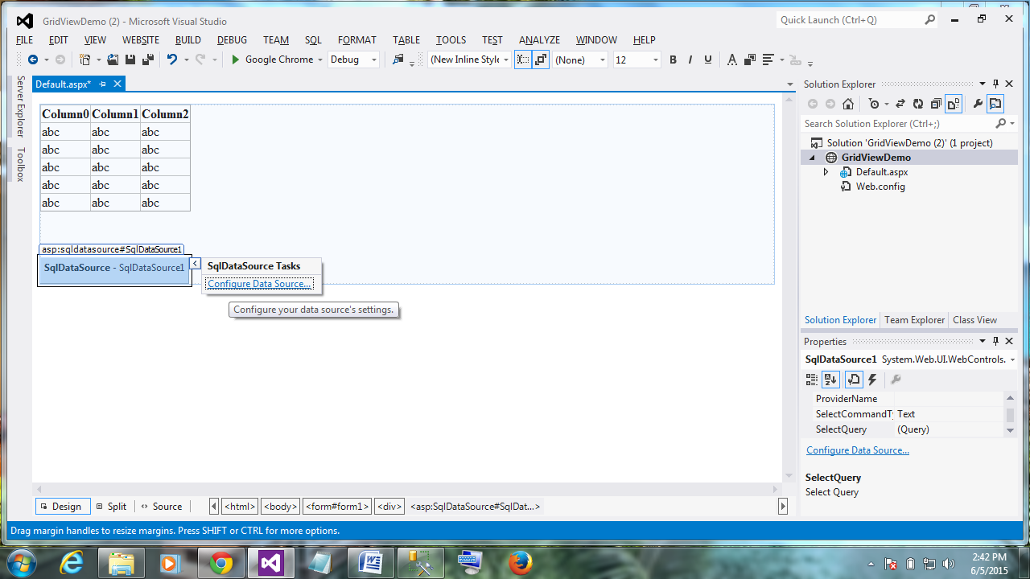

Configure datasource



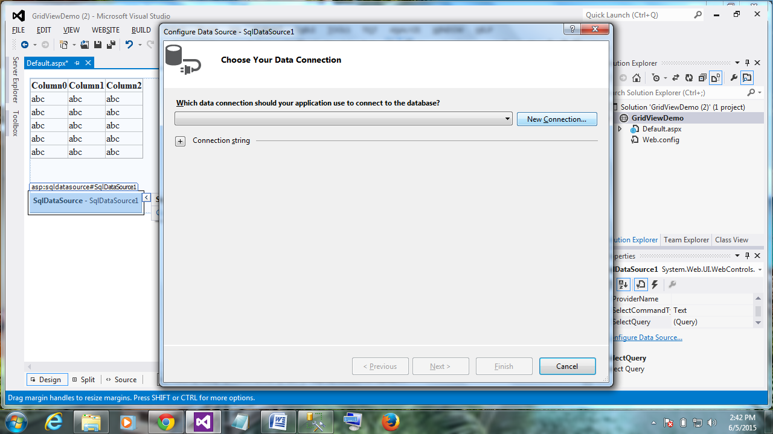

New connection

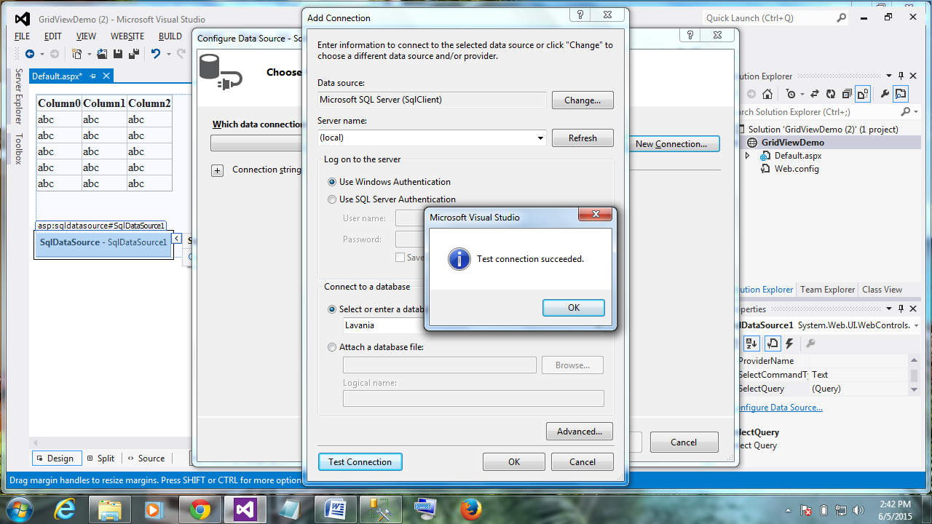

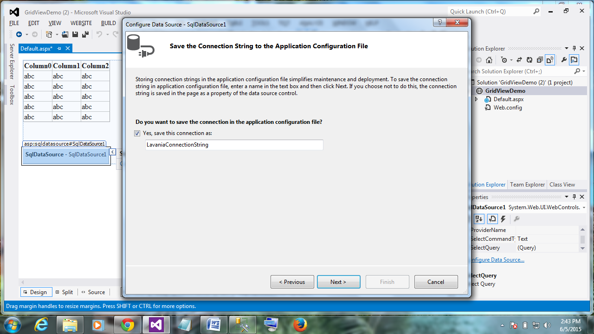

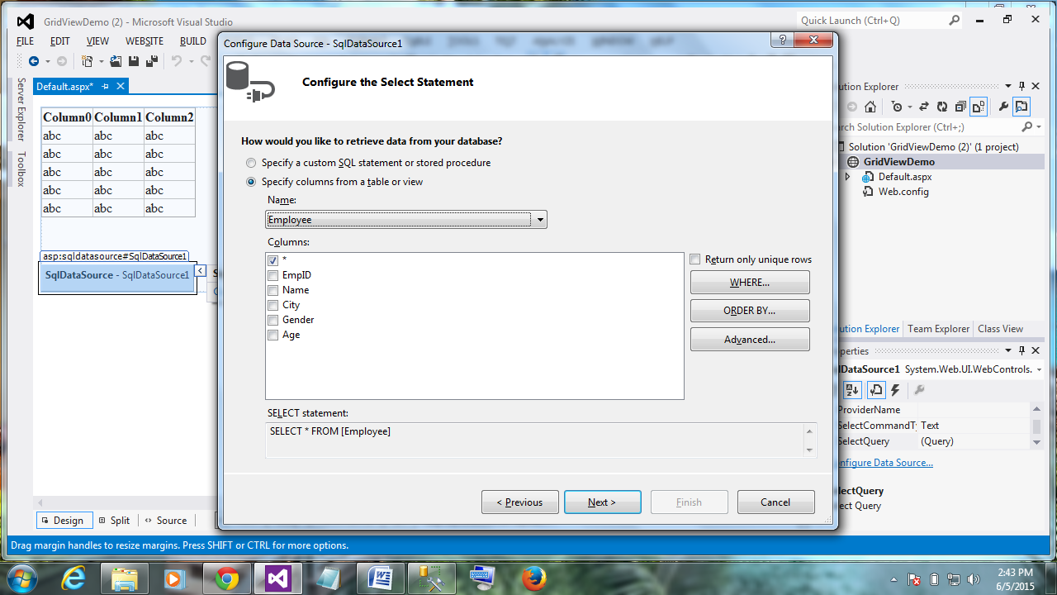

Click on Advance

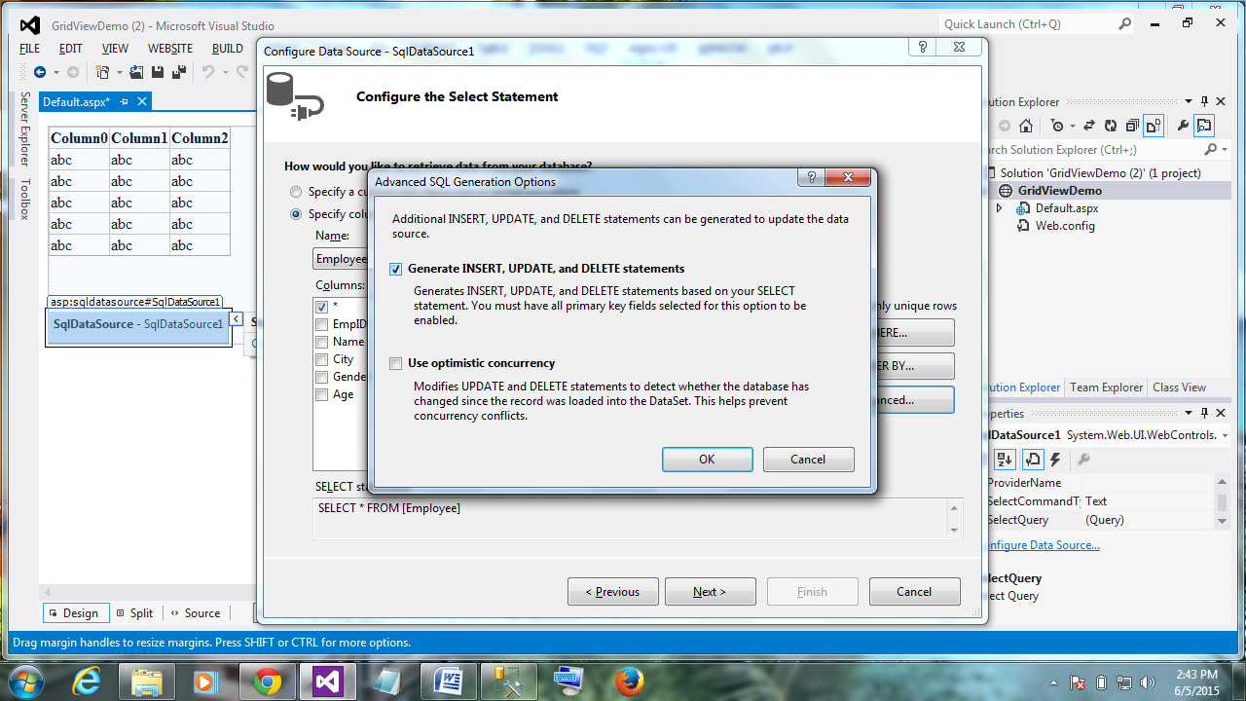

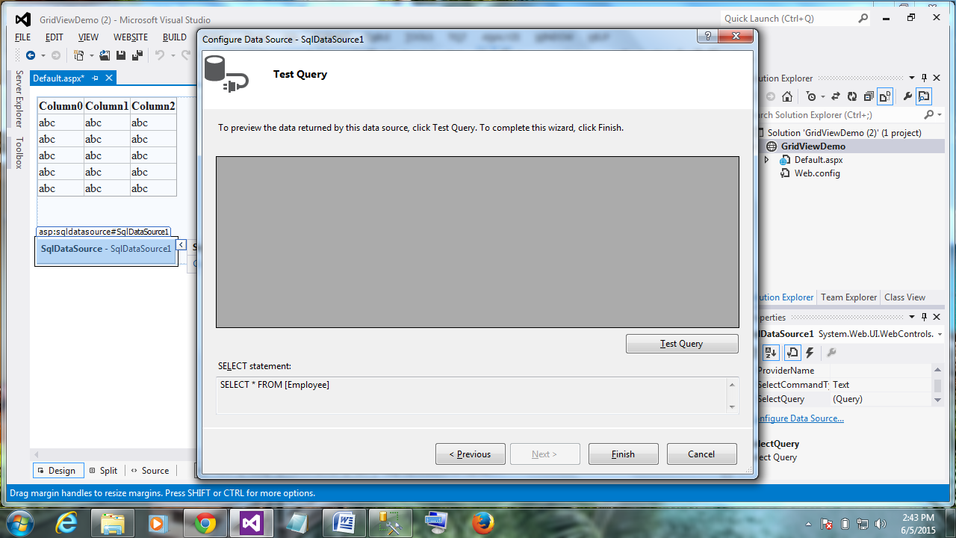

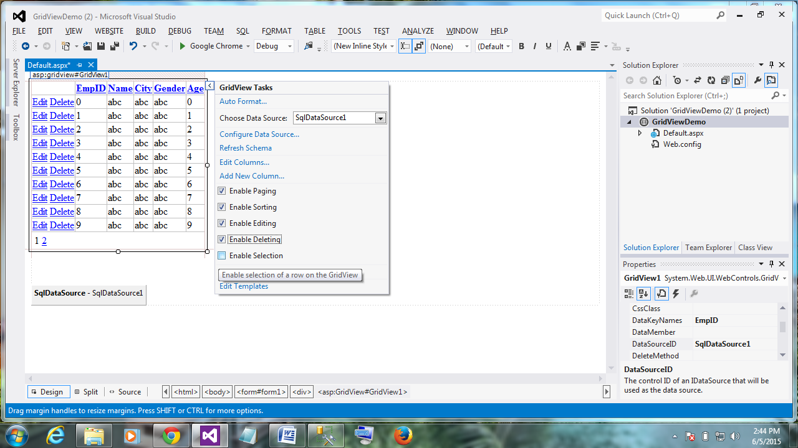

Run it

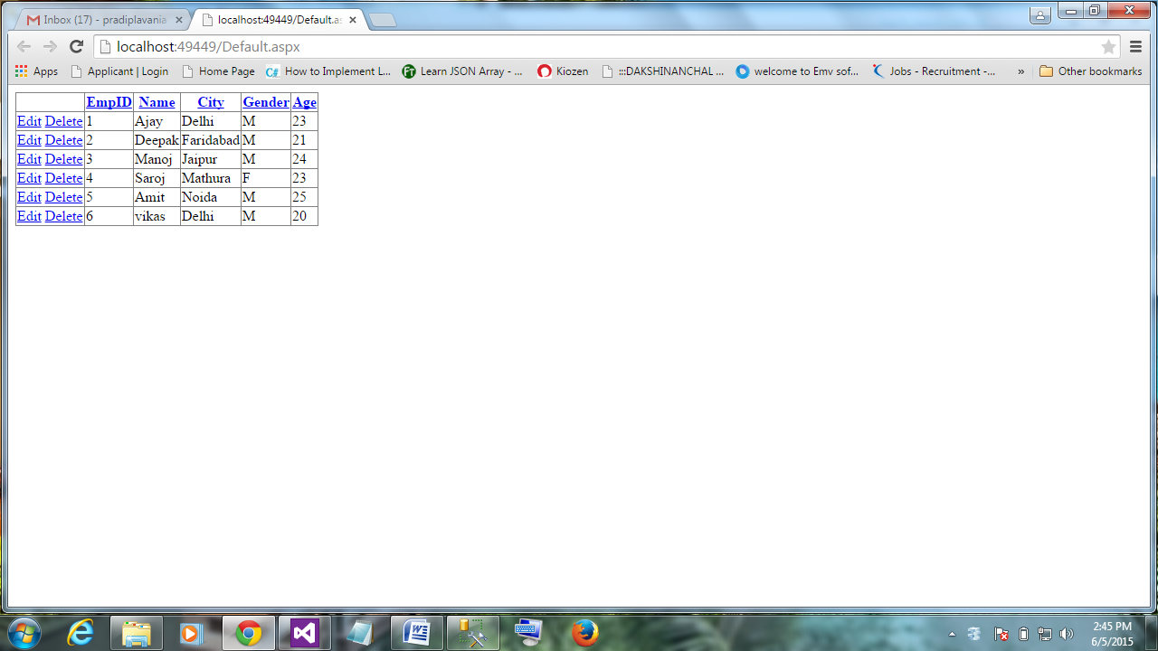

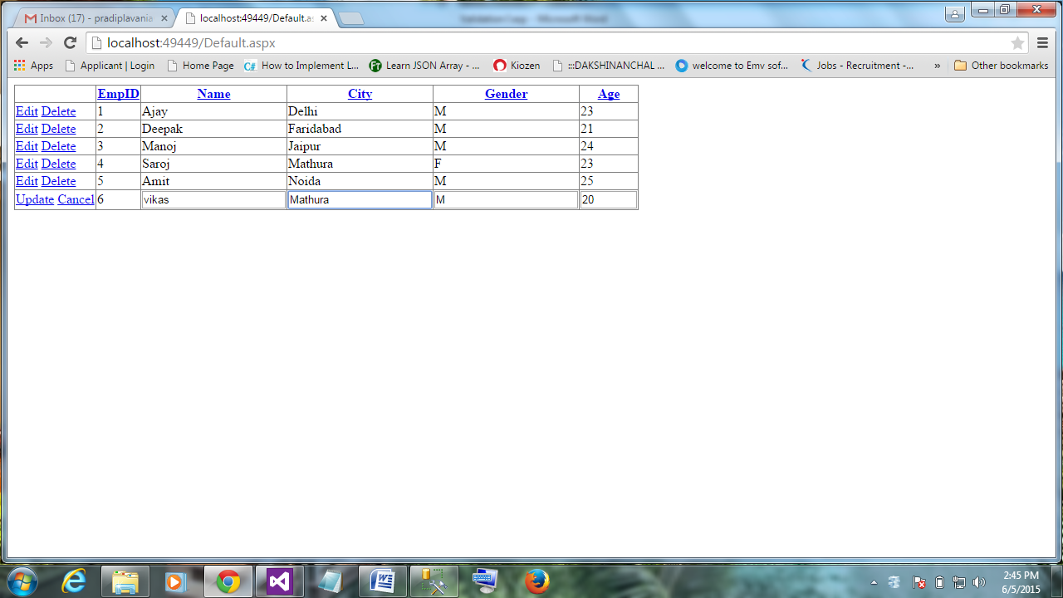

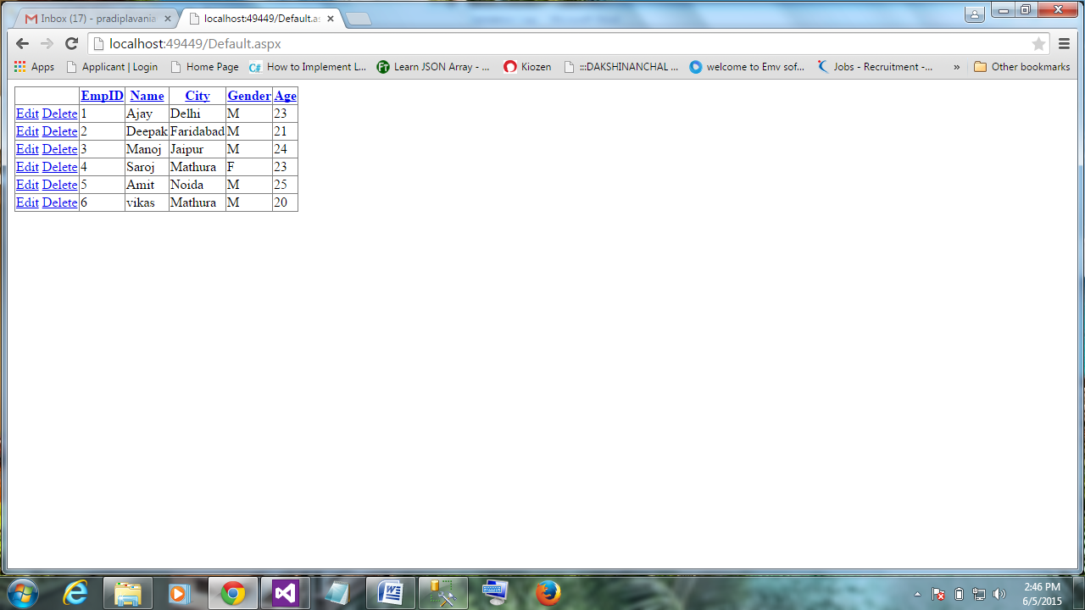

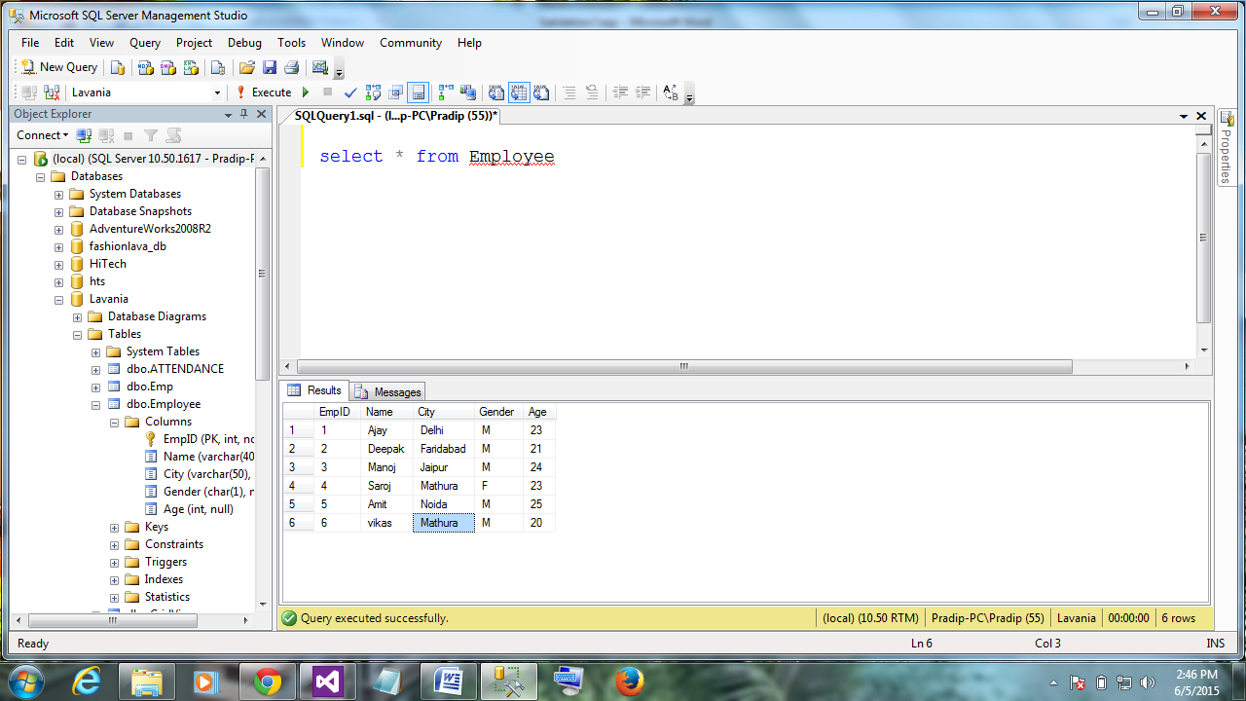

<%@ Page Language="C#" AutoEventWireup="true" CodeFile="Default.aspx.cs" Inherits="_Default" %>

<!DOCTYPE html>

<html xmlns="http://www.w3.org/1999/xhtml">

<head runat="server">

<title></title>

</head>

<body>

<form id="form1" runat="server">

<div>

<asp:GridView ID="GridView1" runat="server" AllowPaging="True" AllowSorting="True" AutoGenerateColumns="False" DataKeyNames="EmpID" DataSourceID="SqlDataSource1">

<Columns>

<asp:CommandField ShowDeleteButton="True" ShowEditButton="True" />

<asp:BoundField DataField="EmpID" HeaderText="EmpID" ReadOnly="True" SortExpression="EmpID" />

<asp:BoundField DataField="Name" HeaderText="Name" SortExpression="Name" />

<asp:BoundField DataField="City" HeaderText="City" SortExpression="City" />

<asp:BoundField DataField="Gender" HeaderText="Gender" SortExpression="Gender" />

<asp:BoundField DataField="Age" HeaderText="Age" SortExpression="Age" />

</Columns>

</asp:GridView>

<br />

<br />

<asp:SqlDataSource ID="SqlDataSource1" runat="server" ConnectionString="<%$ ConnectionStrings:LavaniaConnectionString %>" DeleteCommand="DELETE FROM [Employee] WHERE [EmpID] = @EmpID" InsertCommand="INSERT INTO [Employee] ([EmpID], [Name], [City], [Gender], [Age]) VALUES (@EmpID, @Name, @City, @Gender, @Age)" SelectCommand="SELECT * FROM [Employee]" UpdateCommand="UPDATE [Employee] SET [Name] = @Name, [City] = @City, [Gender] = @Gender, [Age] = @Age WHERE [EmpID] = @EmpID">

<DeleteParameters>

<asp:Parameter Name="EmpID" Type="Int32" />

</DeleteParameters>

<InsertParameters>

<asp:Parameter Name="EmpID" Type="Int32" />

<asp:Parameter Name="Name" Type="String" />

<asp:Parameter Name="City" Type="String" />

<asp:Parameter Name="Gender" Type="String" />

<asp:Parameter Name="Age" Type="Int32" />

</InsertParameters>

<UpdateParameters>

<asp:Parameter Name="Name" Type="String" />

<asp:Parameter Name="City" Type="String" />

<asp:Parameter Name="Gender" Type="String" />

<asp:Parameter Name="Age" Type="Int32" />

<asp:Parameter Name="EmpID" Type="Int32" />

</UpdateParameters>

</asp:SqlDataSource>

</div>

</form>

</body>

</html>

Web.config

<?xml version="1.0"?>

<!--

For more information on how to configure your ASP.NET application, please visit

http://go.microsoft.com/fwlink/?LinkId=169433

-->

<configuration>

<connectionStrings>

<add name="LavaniaConnectionString" connectionString="Data Source=(local);Initial Catalog=Lavania;Integrated Security=True" providerName="System.Data.SqlClient"/>

</connectionStrings>

<system.web>

<compilation debug="true" targetFramework="4.5"/>

<httpRuntime targetFramework="4.5"/>

</system.web>

</configuration>

GridViewWith DetailsView

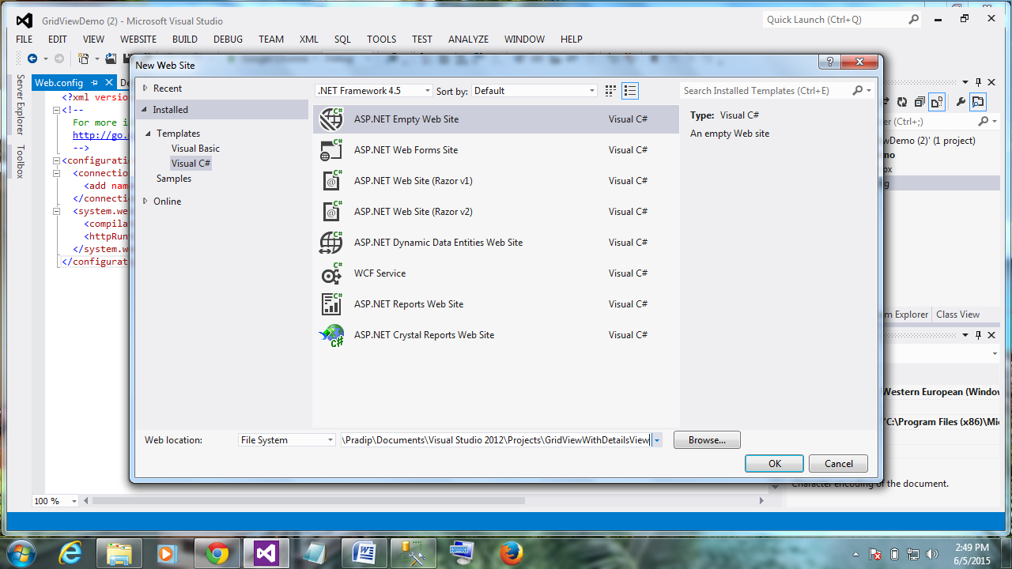

Add a GridView,DetailsView and twio SQLDatasource on page

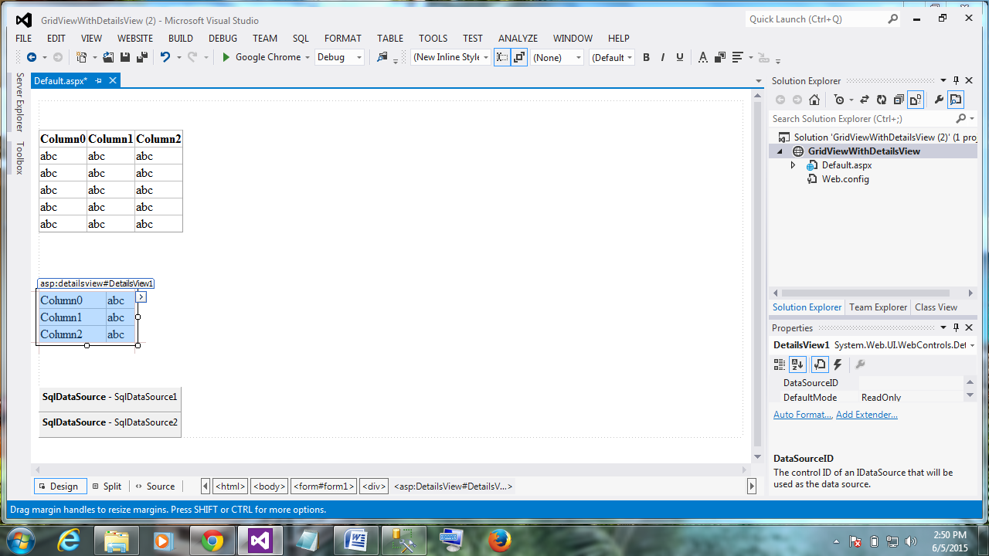

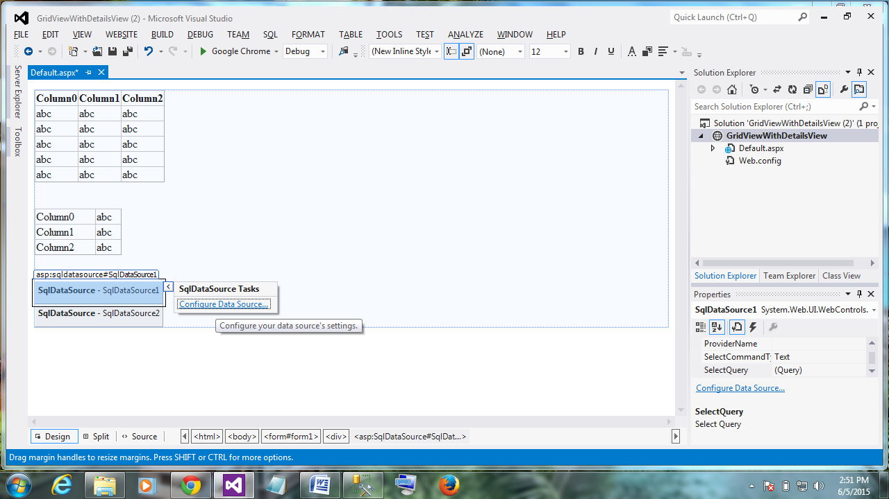

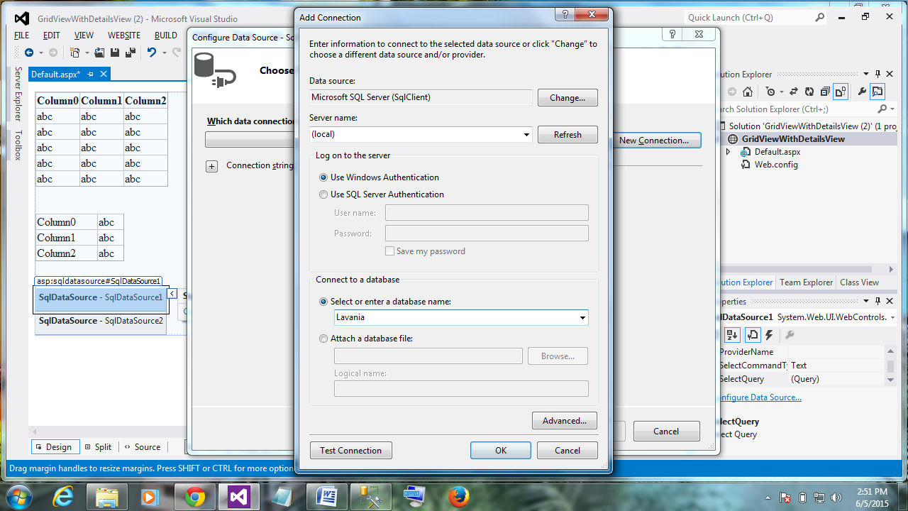

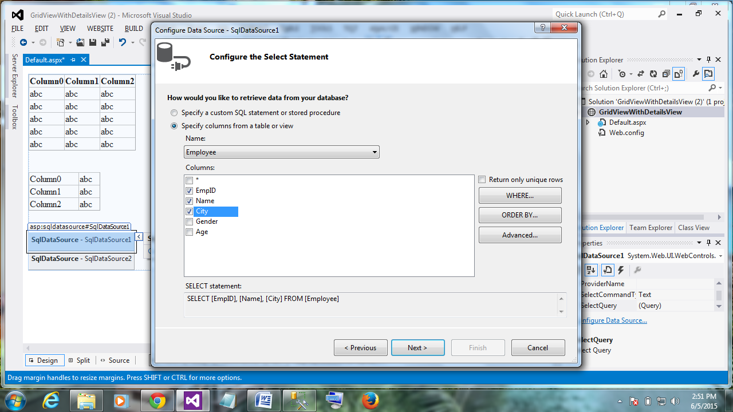

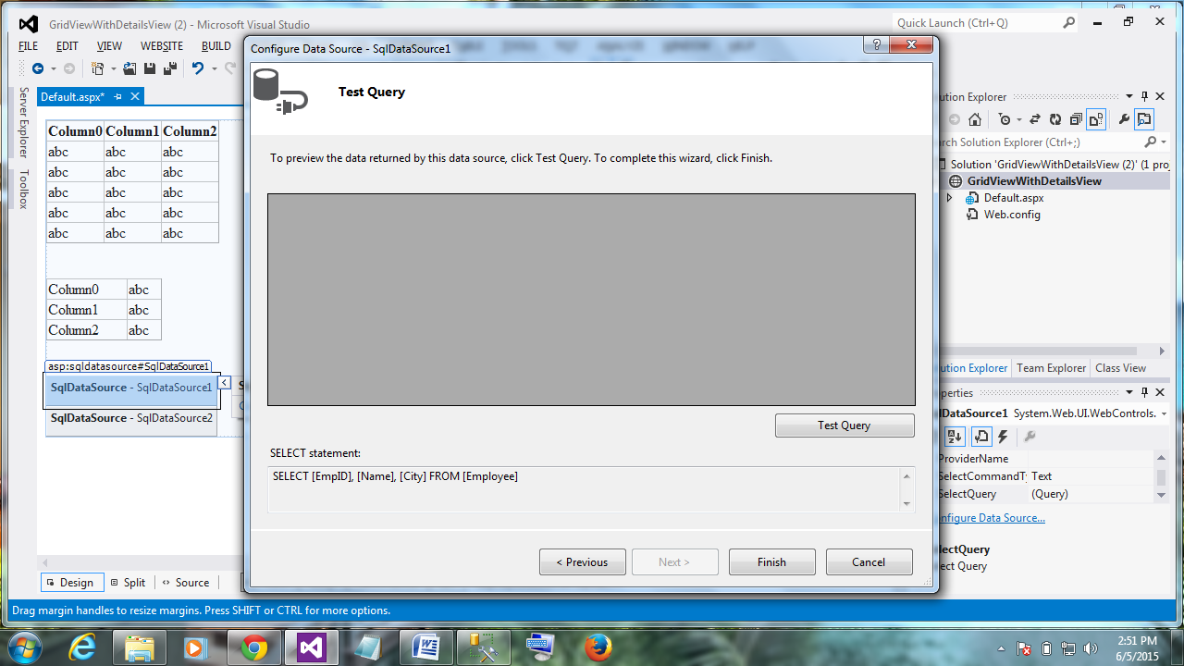

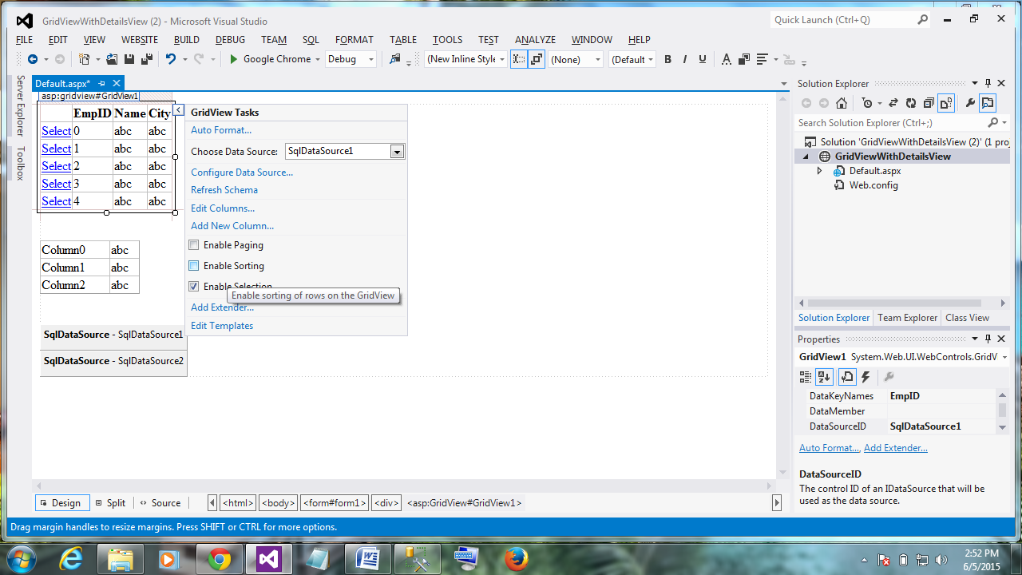

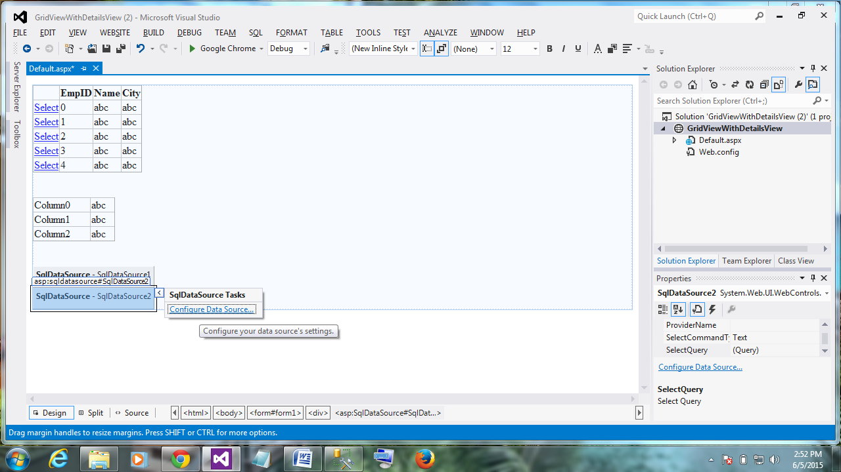

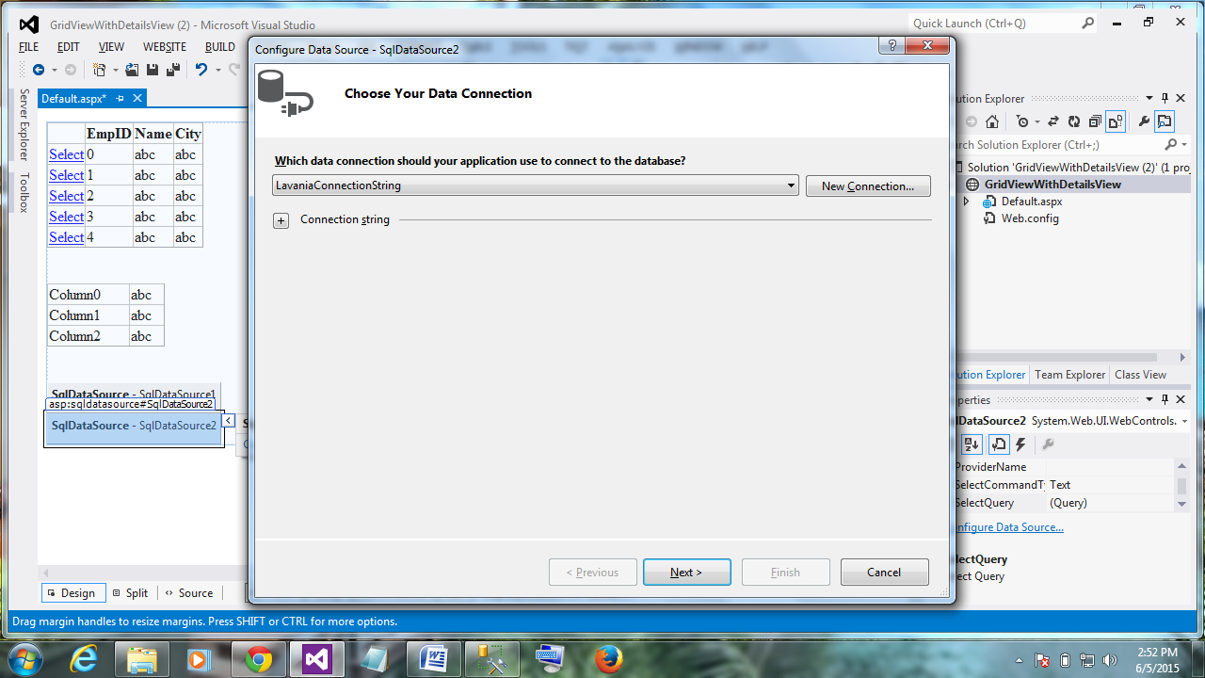

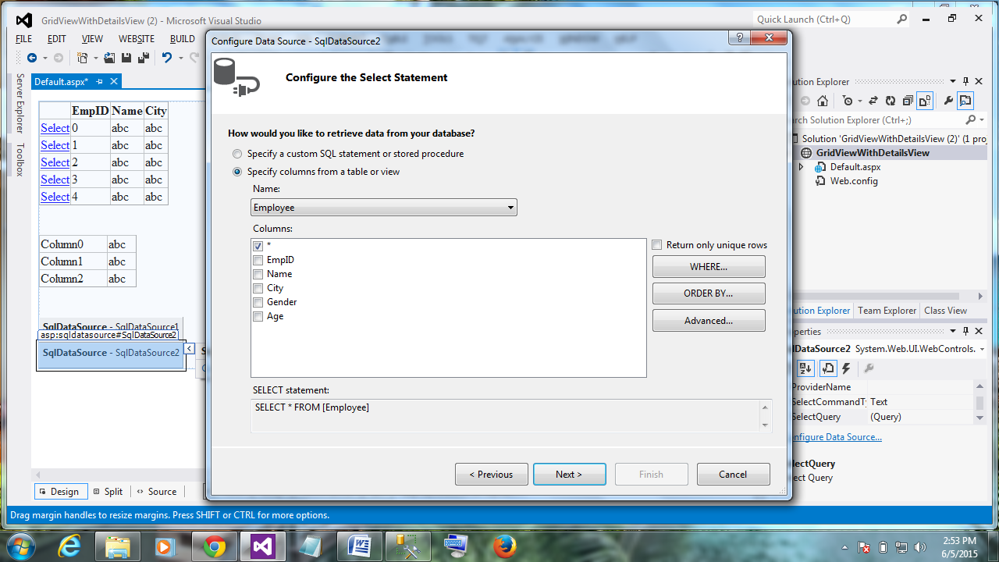

Click on where

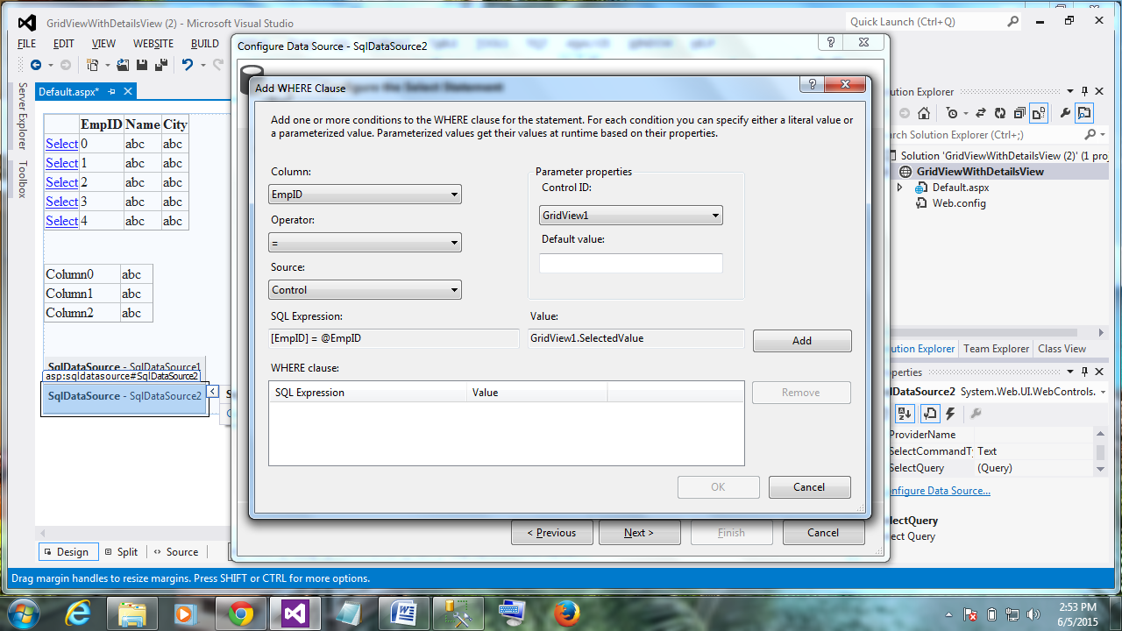

Click Add

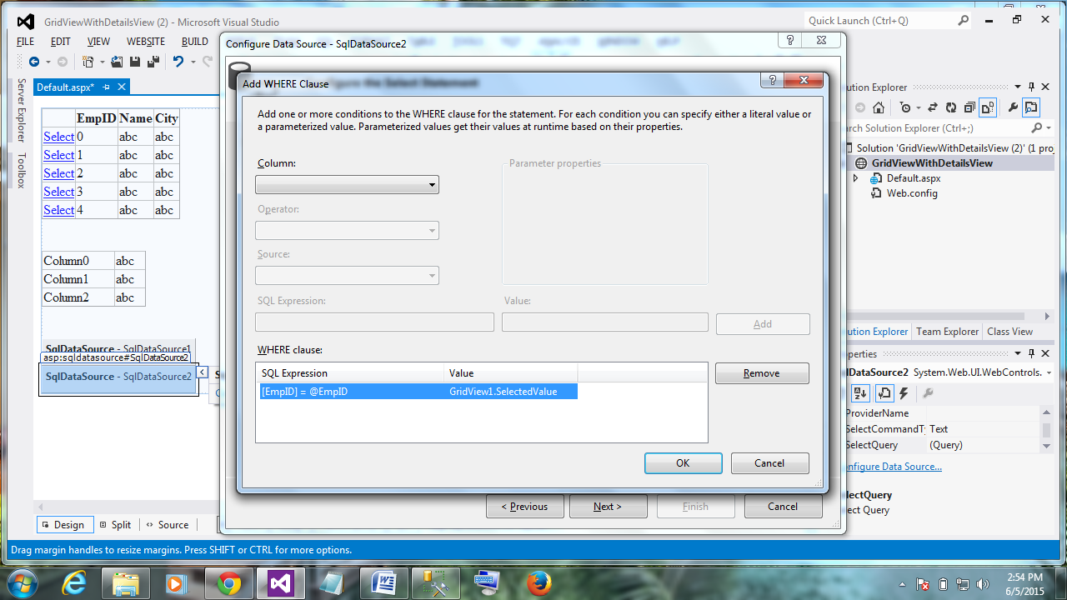

Ok than Advance

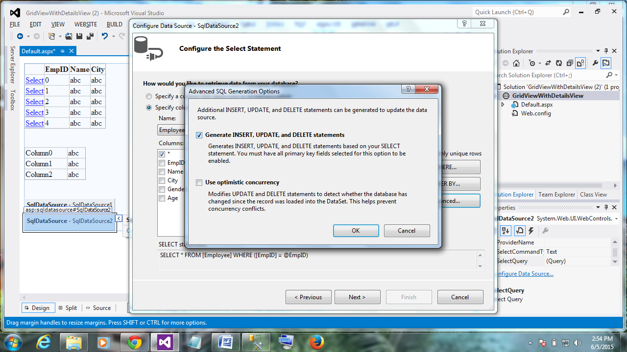

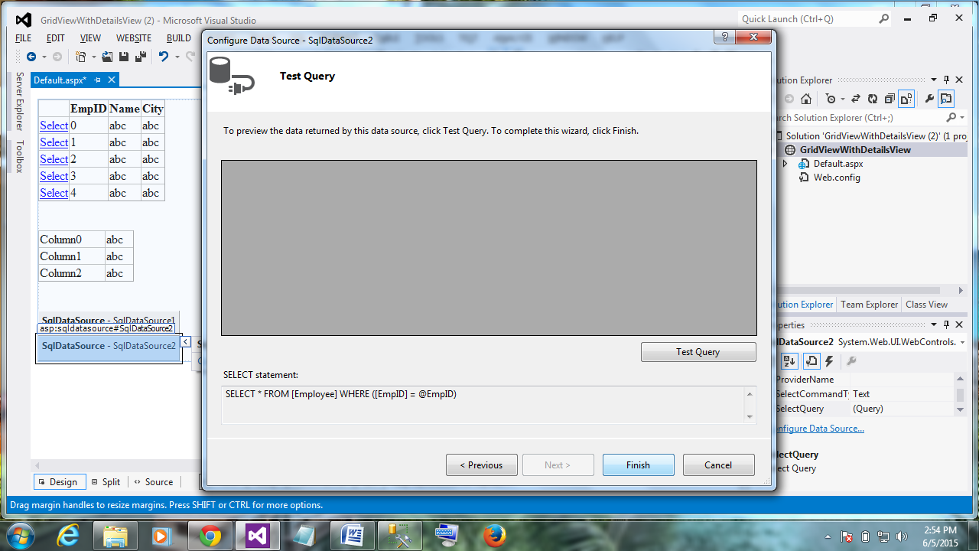

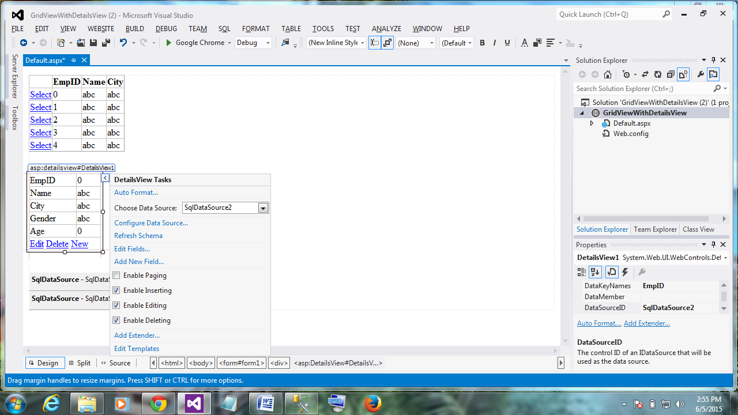

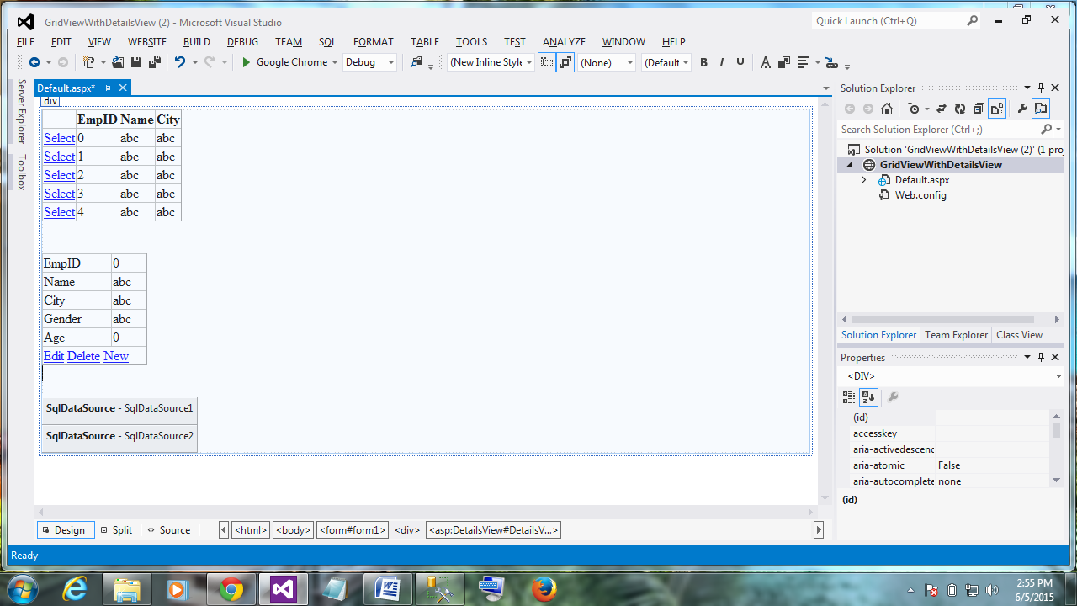

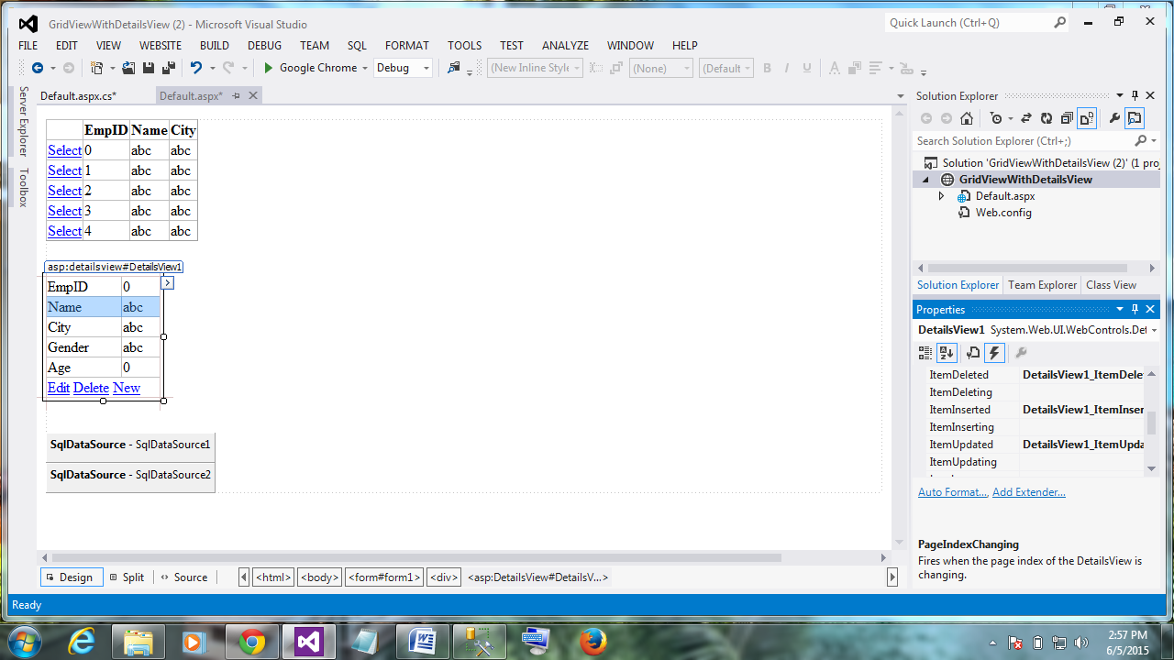

<%@ Page Language="C#" AutoEventWireup="true" CodeFile="Default.aspx.cs" Inherits="_Default" %>

<!DOCTYPE html>

<html xmlns="http://www.w3.org/1999/xhtml">

<head runat="server">

<title></title>

</head>

<body>

<form id="form1" runat="server">

<div>

<asp:GridView ID="GridView1" runat="server" AutoGenerateColumns="False" DataKeyNames="EmpID" DataSourceID="SqlDataSource1">

<Columns>

<asp:CommandField ShowSelectButton="True" />

<asp:BoundField DataField="EmpID" HeaderText="EmpID" ReadOnly="True" SortExpression="EmpID" />

<asp:BoundField DataField="Name" HeaderText="Name" SortExpression="Name" />

<asp:BoundField DataField="City" HeaderText="City" SortExpression="City" />

</Columns>

</asp:GridView>

<br />

<asp:DetailsView ID="DetailsView1" runat="server" AutoGenerateRows="False" DataKeyNames="EmpID" DataSourceID="SqlDataSource2" Height="50px" OnItemDeleted="DetailsView1_ItemDeleted" OnItemInserted="DetailsView1_ItemInserted" OnItemUpdated="DetailsView1_ItemUpdated" Width="125px">

<Fields>

<asp:BoundField DataField="EmpID" HeaderText="EmpID" ReadOnly="True" SortExpression="EmpID" />

<asp:BoundField DataField="Name" HeaderText="Name" SortExpression="Name" />

<asp:BoundField DataField="City" HeaderText="City" SortExpression="City" />

<asp:BoundField DataField="Gender" HeaderText="Gender" SortExpression="Gender" />

<asp:BoundField DataField="Age" HeaderText="Age" SortExpression="Age" />

<asp:CommandField ShowDeleteButton="True" ShowEditButton="True" ShowInsertButton="True" />

</Fields>

</asp:DetailsView>

<br />

<asp:SqlDataSource ID="SqlDataSource1" runat="server" ConnectionString="<%$ ConnectionStrings:LavaniaConnectionString %>" SelectCommand="SELECT [EmpID], [Name], [City] FROM [Employee]"></asp:SqlDataSource>

<asp:SqlDataSource ID="SqlDataSource2" runat="server" ConnectionString="<%$ ConnectionStrings:LavaniaConnectionString %>" DeleteCommand="DELETE FROM [Employee] WHERE [EmpID] = @EmpID" InsertCommand="INSERT INTO [Employee] ([EmpID], [Name], [City], [Gender], [Age]) VALUES (@EmpID, @Name, @City, @Gender, @Age)" SelectCommand="SELECT * FROM [Employee] WHERE ([EmpID] = @EmpID)" UpdateCommand="UPDATE [Employee] SET [Name] = @Name, [City] = @City, [Gender] = @Gender, [Age] = @Age WHERE [EmpID] = @EmpID">

<DeleteParameters>

<asp:Parameter Name="EmpID" Type="Int32" />

</DeleteParameters>

<InsertParameters>

<asp:Parameter Name="EmpID" Type="Int32" />

<asp:Parameter Name="Name" Type="String" />

<asp:Parameter Name="City" Type="String" />

<asp:Parameter Name="Gender" Type="String" />

<asp:Parameter Name="Age" Type="Int32" />

</InsertParameters>

<SelectParameters>

<asp:ControlParameter ControlID="GridView1" Name="EmpID" PropertyName="SelectedValue" Type="Int32" />

</SelectParameters>

<UpdateParameters>

<asp:Parameter Name="Name" Type="String" />

<asp:Parameter Name="City" Type="String" />

<asp:Parameter Name="Gender" Type="String" />

<asp:Parameter Name="Age" Type="Int32" />

<asp:Parameter Name="EmpID" Type="Int32" />

</UpdateParameters>

</asp:SqlDataSource>

</div>

</form>

</body>

</html>

using System;

using System.Collections.Generic;

using System.Linq;

using System.Web;

using System.Web.UI;

using System.Web.UI.WebControls;

public partial class _Default : System.Web.UI.Page

{

protected void Page_Load(object sender, EventArgs e)

{

}

protected void DetailsView1_ItemDeleted(object sender, DetailsViewDeletedEventArgs e)

{

GridView1.DataBind();

GridView1.SelectedIndex = -1;

}

protected void DetailsView1_ItemInserted(object sender, DetailsViewInsertedEventArgs e)

{

GridView1.DataBind();

GridView1.SelectedIndex = -1;

}

protected void DetailsView1_ItemUpdated(object sender, DetailsViewUpdatedEventArgs e)

{

GridView1.DataBind();

GridView1.SelectedIndex = -1;

}

}

Run it

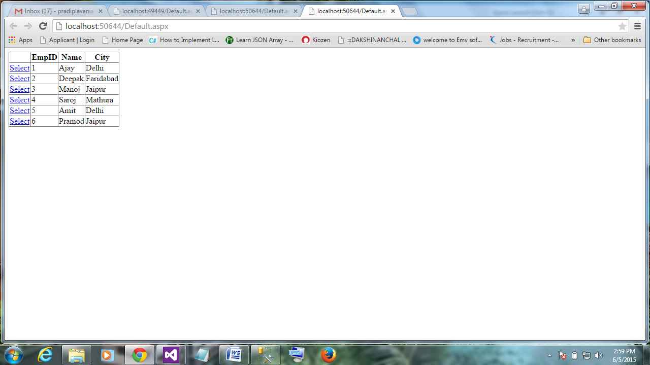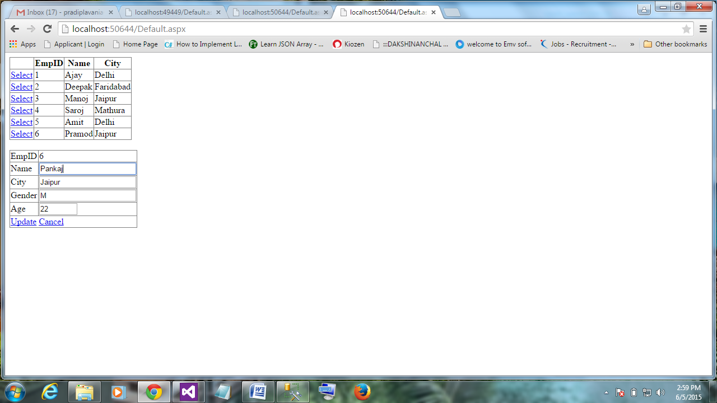

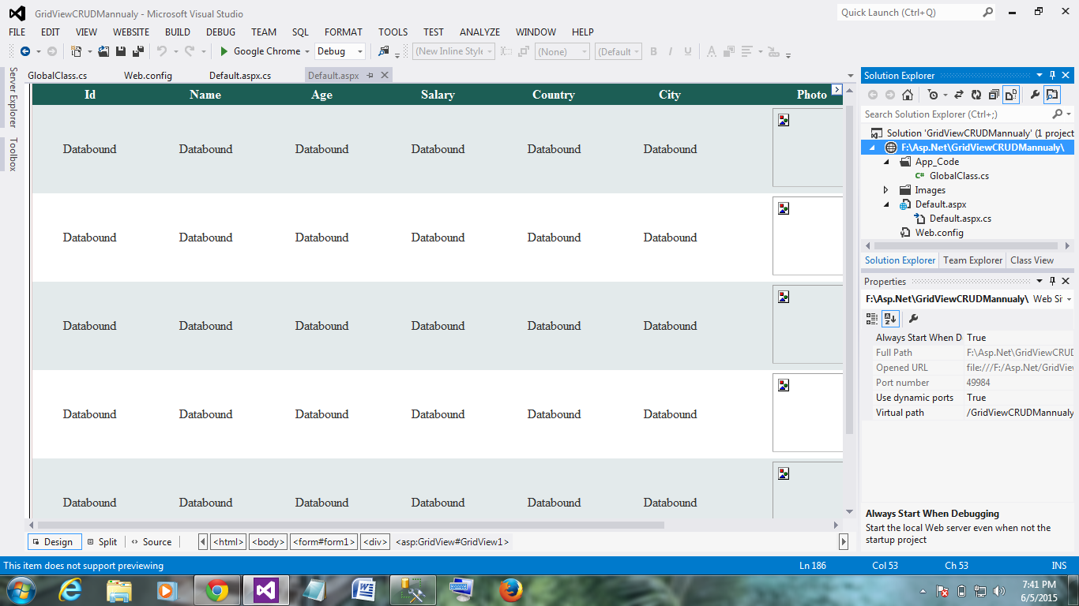

Default.aspx

<%@ Page Language="C#" AutoEventWireup="true" CodeFile="Default.aspx.cs" Inherits="_Default" %>

<!DOCTYPE html>

<html xmlns="http://www.w3.org/1999/xhtml">

<head runat="server">

<title></title>

</head>

<body>

<form id="form1" runat="server">

<div>

<asp:GridView ID="GridView1" runat="server" ShowHeaderWhenEmpty="True"

AutoGenerateColumns="False" onrowdeleting="RowDeleting"

OnRowCancelingEdit="cancelRecord" OnRowEditing="editRecord"

OnRowUpdating="updateRecord" CellPadding="4"

EnableModelValidation="True" GridLines="None" Width="1297px"

ForeColor="#333333" >

<RowStyle HorizontalAlign="Center" />

<AlternatingRowStyle BackColor="White" />

<EditRowStyle BackColor="#7C6F57" />

<FooterStyle BackColor="#1C5E55" ForeColor="White" Font-Bold="True" />

<HeaderStyle BackColor="#1C5E55" Font-Bold="True" ForeColor="White" />

<PagerStyle BackColor="#666666" ForeColor="White" HorizontalAlign="Center" />

<RowStyle BackColor="#E3EAEB" />

<SelectedRowStyle BackColor="#C5BBAF" Font-Bold="True" ForeColor="#333333" />

<Columns>

<asp:TemplateField>

<HeaderTemplate>Id</HeaderTemplate>

<ItemTemplate>

<asp:Label ID ="lblId" runat="server" Text='<%#Bind("id")%>'></asp:Label>

</ItemTemplate>

</asp:TemplateField>

<asp:TemplateField>

<HeaderTemplate>Name</HeaderTemplate>

<ItemTemplate>

<asp:Label ID ="lblName" runat="server" Text='<%#Bind("name") %>'></asp:Label>

</ItemTemplate>

<EditItemTemplate>

<asp:TextBox ID="txtName" runat="server" Text='<%#Bind("name") %>' MaxLength="50"></asp:TextBox>

<asp:RequiredFieldValidator ID="rfvtxtName" runat="server" Text="*" ToolTip="Enter name" ControlToValidate="txtName"></asp:RequiredFieldValidator>

<asp:RegularExpressionValidator ID="revtxtName" runat="server" Text="*" ToolTip="Enter alphabate " ControlToValidate="txtName" ValidationExpression="^[a-zA-Z'.\s]{1,40}$"></asp:RegularExpressionValidator>

</EditItemTemplate>

<FooterTemplate>

<asp:TextBox ID="txtNewName" runat="server" MaxLength="50"></asp:TextBox>

<asp:RequiredFieldValidator ID="rfvtxtNewName" runat="server" Text="*" ToolTip="Enter name" ControlToValidate="txtNewName"></asp:RequiredFieldValidator>

<asp:RegularExpressionValidator ID="revtxtNewName" runat="server" Text="*" ToolTip="Enter alphabate " ControlToValidate="txtNewName" ValidationExpression="^[a-zA-Z'.\s]{1,40}$"></asp:RegularExpressionValidator>

</FooterTemplate>

</asp:TemplateField>

<asp:TemplateField>

<HeaderTemplate>Age</HeaderTemplate>

<ItemTemplate>

<asp:Label ID="lblAge" runat ="server" Text='<%#Bind("age") %>'></asp:Label>

</ItemTemplate>

<EditItemTemplate>

<asp:TextBox ID ="txtAge" runat="server" Text='<%#Bind("age") %>' MaxLength="2"></asp:TextBox>

<asp:RequiredFieldValidator ID="rfvtxtAge" runat="server" Text="*" ToolTip="Enter age" ControlToValidate="txtAge"></asp:RequiredFieldValidator>

<asp:RegularExpressionValidator ID="revtxtAge" runat="server" Text="*" ToolTip="Enter numeric value" ControlToValidate="txtAge" ValidationExpression="^[0-9]+$"></asp:RegularExpressionValidator>

</EditItemTemplate>

<FooterTemplate>

<asp:TextBox ID="txtNewAge" runat="server" MaxLength="2"></asp:TextBox>

<asp:RequiredFieldValidator ID="rfvtxtNewAge" runat="server" Text="*" ToolTip="Enter age" ControlToValidate="txtNewAge"></asp:RequiredFieldValidator>

<asp:RegularExpressionValidator ID="revNewtxtAge" runat="server" Text="*" ToolTip="Enter numeric value" ControlToValidate="txtNewAge" ValidationExpression="^[0-9]+$"></asp:RegularExpressionValidator>

</FooterTemplate>

</asp:TemplateField>

<asp:TemplateField>

<HeaderTemplate>Salary</HeaderTemplate>

<ItemTemplate>

<asp:Label ID = "lblSalary" runat="server" Text='<%#Bind("salary") %>'></asp:Label>

</ItemTemplate>

<EditItemTemplate>

<asp:TextBox ID="txtSalary" runat="server" Text='<%#Bind("salary") %>' MaxLength="10"></asp:TextBox>

<asp:RequiredFieldValidator ID="rfvtxtSalary" runat="server" Text="*" ToolTip="Enter salary" ControlToValidate="txtSalary"></asp:RequiredFieldValidator>

<asp:RegularExpressionValidator ID="revtxtSalary" runat="server" Text="*" ToolTip="Enter numeric value" ControlToValidate="txtSalary" ValidationExpression="^[0-9]+$"></asp:RegularExpressionValidator>

</EditItemTemplate>

<FooterTemplate>

<asp:TextBox ID="txtNewSalary" runat="server" MaxLength="10"></asp:TextBox>

<asp:RequiredFieldValidator ID="rfvtxtNewSalary" runat="server" Text="*" ToolTip="Enter salary" ControlToValidate="txtNewSalary"></asp:RequiredFieldValidator>

<asp:RegularExpressionValidator ID="revtxtNewSalary" runat="server" Text="*" ToolTip="Enter numeric value" ControlToValidate="txtNewSalary" ValidationExpression="^[0-9]+$"></asp:RegularExpressionValidator>

</FooterTemplate>

</asp:TemplateField>

<asp:TemplateField>

<HeaderTemplate>Country</HeaderTemplate>

<ItemTemplate>

<asp:Label ID = "lblCountry" runat="server" Text='<%#Bind("country") %>'></asp:Label>

</ItemTemplate>

<EditItemTemplate>

<asp:TextBox ID="txtCountry" runat="server" Text='<%#Bind("country") %>' MaxLength="20"></asp:TextBox>

<asp:RequiredFieldValidator ID="rfvtxtCountry" runat="server" Text="*" ToolTip="Enter country" ControlToValidate="txtCountry"></asp:RequiredFieldValidator>

</EditItemTemplate>

<FooterTemplate>

<asp:TextBox ID="txtNewCountry" runat="server" MaxLength="20"></asp:TextBox>

<asp:RequiredFieldValidator ID="rfvtxtNewCountry" runat="server" Text="*" ToolTip="Enter country" ControlToValidate="txtNewCountry"></asp:RequiredFieldValidator>

</FooterTemplate>

</asp:TemplateField>

<asp:TemplateField>

<HeaderTemplate>City</HeaderTemplate>

<ItemTemplate>

<asp:Label ID = "lblCity" runat="server" Text='<%#Bind("city") %>'></asp:Label>

</ItemTemplate>

<EditItemTemplate>

<asp:TextBox ID="txtCity" runat="server" Text='<%#Bind("city") %>' MaxLength="20"></asp:TextBox>

<asp:RequiredFieldValidator ID="rfvtxtCity" runat="server" Text="*" ToolTip="Enter city" ControlToValidate="txtCity"></asp:RequiredFieldValidator>

</EditItemTemplate>

<FooterTemplate>

<asp:TextBox ID="txtNewCity" runat="server" MaxLength="20"></asp:TextBox>

<asp:RequiredFieldValidator ID="rfvtxtNewCity" runat="server" Text="*" ToolTip="Enter city" ControlToValidate="txtNewCity"></asp:RequiredFieldValidator>

</FooterTemplate>

</asp:TemplateField>

<asp:TemplateField>

<HeaderTemplate>Photo</HeaderTemplate>

<ItemTemplate>

<asp:Image ID="imgPhoto" Width="100px" Height="100px" runat="server" text="Photo" ImageUrl='<%#Bind("photopath") %>' />

</ItemTemplate>

<EditItemTemplate>

<asp:FileUpload ID="fuPhoto" runat="server" ToolTip="select Employee Photo"/>

<asp:RegularExpressionValidator ID="revfuPhoto" runat="server" Text="*" ToolTip="Image formate only" ControlToValidate="fuPhoto" ValidationExpression="[a-zA-Z0_9].*\b(.jpeg|.JPEG|.jpg|.JPG|.jpe|.JPE|.png|.PNG|.mpp|.MPP|.gif|.GIF)\b"></asp:RegularExpressionValidator>

</EditItemTemplate>

<FooterTemplate>

<asp:FileUpload ID="fuNewPhoto" runat="server" ToolTip="select Employee Photo"/>

<asp:RequiredFieldValidator ID="rfvfuNewPhoto" runat="server" ErrorMessage="*" ToolTip="Select Photo" ControlToValidate="fuNewPhoto"></asp:RequiredFieldValidator>

<asp:RegularExpressionValidator ID="revfuNewPhoto" runat="server" Text="*" ToolTip="Image formate only" ControlToValidate="fuNewPhoto" ValidationExpression="[a-zA-Z0_9].*\b(.jpeg|.JPEG|.jpg|.JPG|.jpe|.JPE|.png|.PNG|.mpp|.MPP|.gif|.GIF)\b"></asp:RegularExpressionValidator>

</FooterTemplate>

</asp:TemplateField>

<asp:TemplateField>

<HeaderTemplate>Operation</HeaderTemplate>

<ItemTemplate>

<asp:Button ID="btnEdit" runat="server" CommandName="Edit" Text="Edit" />

<asp:Button ID="btnDelete" runat="server" CommandName="Delete" Text="Delete" CausesValidation="true" OnClientClick="return confirm('Are you sure?')" />

</ItemTemplate>

<EditItemTemplate>

<asp:Button ID="btnUpdate" runat="server" CommandName="Update" Text="Update" />

<asp:Button ID="btnCancel" runat="server" CommandName="Cancel" Text="Cancel" CausesValidation="false" />

</EditItemTemplate>

<FooterTemplate>

<asp:Button ID="btnNewInsert" runat="server" Text="Insert" OnClick="InsertNewRecord"/>

<asp:Button ID="btnNewCancel" runat="server" Text="Cancel" OnClick="AddNewCancel" CausesValidation="false" />

</FooterTemplate>

</asp:TemplateField>

</Columns>

<EmptyDataTemplate>

No record available

</EmptyDataTemplate>

</asp:GridView>

<br />

<asp:Button ID="btnAdd" runat="server" Text="Add New Record" OnClick="AddNewRecord" />

</div>

</form>

</body>

</html>

Default.aspx.cs

using System;

using System.Collections.Generic;

using System.Linq;

using System.Web;

using System.Web.UI;

using System.Web.UI.WebControls;

using System.Data;

using System.Data.SqlClient;

using System.Configuration;

using System.IO;

public partial class _Default : System.Web.UI.Page

{

protected void Page_Load(object sender, EventArgs e)

{

if (!IsPostBack)

{

// Call FillGridView Method

FillGridView();

}

}

/// <summary>

/// Fill record into GridView

/// </summary>

public void FillGridView()

{

try

{

string cnString = ConfigurationManager.ConnectionStrings["dbconnection"].ConnectionString;

SqlConnection con = new SqlConnection(cnString);

GlobalClass.adap = new SqlDataAdapter("select * from gridview", con);

SqlCommandBuilder bui = new SqlCommandBuilder(GlobalClass.adap);

GlobalClass.dt = new DataTable();

GlobalClass.adap.Fill(GlobalClass.dt);

GridView1.DataSource = GlobalClass.dt;

GridView1.DataBind();

}

catch

{

Response.Write("<script> alert('Connection String Error...') </script>");

}

}

/// <summary>

/// Edit record

/// </summary>

/// <param name="sender"></param>

/// <param name="e"></param>

protected void editRecord(object sender, GridViewEditEventArgs e)

{

// Get the image path for remove old image after update record

Image imgEditPhoto = GridView1.Rows[e.NewEditIndex].FindControl("imgPhoto") as Image;

GlobalClass.imgEditPath = imgEditPhoto.ImageUrl;

// Get the current row index for edit record

GridView1.EditIndex = e.NewEditIndex;

FillGridView();

}

/// <summary>

/// Cancel the operation (e.g. edit)

/// </summary>

/// <param name="sender"></param>

/// <param name="e"></param>

protected void cancelRecord(object sender, GridViewCancelEditEventArgs e)

{

GridView1.EditIndex = -1;

FillGridView();

}

/// <summary>

/// Add new row into DataTable if no record found in Table

/// </summary>

/// <param name="sender"></param>

/// <param name="e"></param>

protected void AddNewRecord(object sender, EventArgs e)

{

try

{

if (GlobalClass.dt.Rows.Count > 0)

{

GridView1.EditIndex = -1;

GridView1.ShowFooter = true;

FillGridView();

}

else

{

GridView1.ShowFooter = true;

DataRow dr = GlobalClass.dt.NewRow();

dr["name"] = "0";

dr["age"] = 0;

dr["salary"] = 0;

dr["country"] = "0";

dr["city"] = "0";

dr["photopath"] = "0";

GlobalClass.dt.Rows.Add(dr);

GridView1.DataSource = GlobalClass.dt;

GridView1.DataBind();

GridView1.Rows[0].Visible = false;

}

}

catch

{

Response.Write("<script> alert('Row not added in DataTable...') </script>");

}

}

/// <summary>

/// Cancel new added record

/// </summary>

/// <param name="sender"></param>

/// <param name="e"></param>

protected void AddNewCancel(object sender, EventArgs e)

{

GridView1.ShowFooter = false;

FillGridView();

}

/// <summary>

/// Insert New Record

/// </summary>

/// <param name="sender"></param>

/// <param name="e"></param>

protected void InsertNewRecord(object sender, EventArgs e)

{

try

{

string strName = GlobalClass.dt.Rows[0]["name"].ToString();

if (strName == "0")

{

GlobalClass.dt.Rows[0].Delete();

GlobalClass.adap.Update(GlobalClass.dt);

}

TextBox txtName = GridView1.FooterRow.FindControl("txtNewName") as TextBox;

TextBox txtAge = GridView1.FooterRow.FindControl("txtNewAge") as TextBox;

TextBox txtSalary = GridView1.FooterRow.FindControl("txtNewSalary") as TextBox;

TextBox txtCountry = GridView1.FooterRow.FindControl("txtNewCountry") as TextBox;

TextBox txtCity = GridView1.FooterRow.FindControl("txtNewCity") as TextBox;

FileUpload fuPhoto = GridView1.FooterRow.FindControl("fuNewPhoto") as FileUpload;

Guid FileName = Guid.NewGuid();

fuPhoto.SaveAs(Server.MapPath("~/Images/" + FileName + ".png"));

DataRow dr = GlobalClass.dt.NewRow();

dr["name"] = txtName.Text.Trim();

dr["age"] = txtAge.Text.Trim();

dr["salary"] = txtSalary.Text.Trim();

dr["country"] = txtCountry.Text.Trim();

dr["city"] = txtCity.Text.Trim();

dr["photopath"] = "~/Images/" + FileName + ".png";

GlobalClass.dt.Rows.Add(dr);

GlobalClass.adap.Update(GlobalClass.dt);

GridView1.ShowFooter = false;

FillGridView();

}

catch

{

Response.Write("<script> alert('Record not added...') </script>");

}

}

/// <summary>

/// Update the record

/// </summary>

/// <param name="sender"></param>

/// <param name="e"></param>

protected void updateRecord(object sender, GridViewUpdateEventArgs e)

{

try

{

TextBox txtName = GridView1.Rows[e.RowIndex].FindControl("txtName") as TextBox;

TextBox txtAge = GridView1.Rows[e.RowIndex].FindControl("txtAge") as TextBox;

TextBox txtSalary = GridView1.Rows[e.RowIndex].FindControl("txtSalary") as TextBox;

TextBox txtCountry = GridView1.Rows[e.RowIndex].FindControl("txtCountry") as TextBox;

TextBox txtCity = GridView1.Rows[e.RowIndex].FindControl("txtCity") as TextBox;

FileUpload fuPhoto = GridView1.Rows[e.RowIndex].FindControl("fuPhoto") as FileUpload;

Guid FileName = Guid.NewGuid();

if (fuPhoto.FileName != "")

{

fuPhoto.SaveAs(Server.MapPath("~/Images/" + FileName + ".png"));

GlobalClass.dt.Rows[GridView1.Rows[e.RowIndex].RowIndex]["photopath"] = "~/Images/" + FileName + ".png";

File.Delete(Server.MapPath(GlobalClass.imgEditPath));

}

GlobalClass.dt.Rows[GridView1.Rows[e.RowIndex].RowIndex]["name"] = txtName.Text.Trim();

GlobalClass.dt.Rows[GridView1.Rows[e.RowIndex].RowIndex]["age"] = Convert.ToInt32(txtAge.Text.Trim());

GlobalClass.dt.Rows[GridView1.Rows[e.RowIndex].RowIndex]["salary"] = Convert.ToInt32(txtSalary.Text.Trim());

GlobalClass.dt.Rows[GridView1.Rows[e.RowIndex].RowIndex]["country"] = txtCountry.Text.Trim();

GlobalClass.dt.Rows[GridView1.Rows[e.RowIndex].RowIndex]["city"] = txtCity.Text.Trim();

GlobalClass.adap.Update(GlobalClass.dt);

GridView1.EditIndex = -1;

FillGridView();

}

catch

{

Response.Write("<script> alert('Record updation fail...') </script>");

}

}

/// <summary>

/// Delete Record

/// </summary>

/// <param name="sender"></param>

/// <param name="e"></param>

protected void RowDeleting(object sender, GridViewDeleteEventArgs e)

{

try

{

GlobalClass.dt.Rows[GridView1.Rows[e.RowIndex].RowIndex].Delete();

GlobalClass.adap.Update(GlobalClass.dt);

// Get the image path for removing deleted's record image from server folder

Image imgPhoto = GridView1.Rows[e.RowIndex].FindControl("imgPhoto") as Image;

File.Delete(Server.MapPath(imgPhoto.ImageUrl));

FillGridView();

}

catch

{

Response.Write("<script> alert('Record not deleted...') </script>");

}

}

}

Web.config file

<?xml version="1.0"?>

<!--

For more information on how to configure your ASP.NET application, please visit

http://go.microsoft.com/fwlink/?LinkId=169433

-->

<configuration>

<system.web>

<compilation debug="true" targetFramework="4.5"/>

<httpRuntime targetFramework="4.5"/>

</system.web>

<connectionStrings>

<add name="dbconnection" providerName="System.Data.SqlClient" connectionString="Data Source=(local);Initial Catalog=Lavania;Integrated Security=true"/>

</connectionStrings>

<appSettings>

<add key="ValidationSettings:UnobtrusiveValidationMode" value="None" />

</appSettings>

</configuration>

using System;

using System.Collections.Generic;

using System.Linq;

using System.Web;

using System.Data;

using System.Data.SqlClient;

/// <summary>

/// Summary description for GlobalClass

/// </summary>

public class GlobalClass

{

public static SqlDataAdapter adap;

public static DataTable dt;

// Stored image path before updating the record

public static string imgEditPath;

}

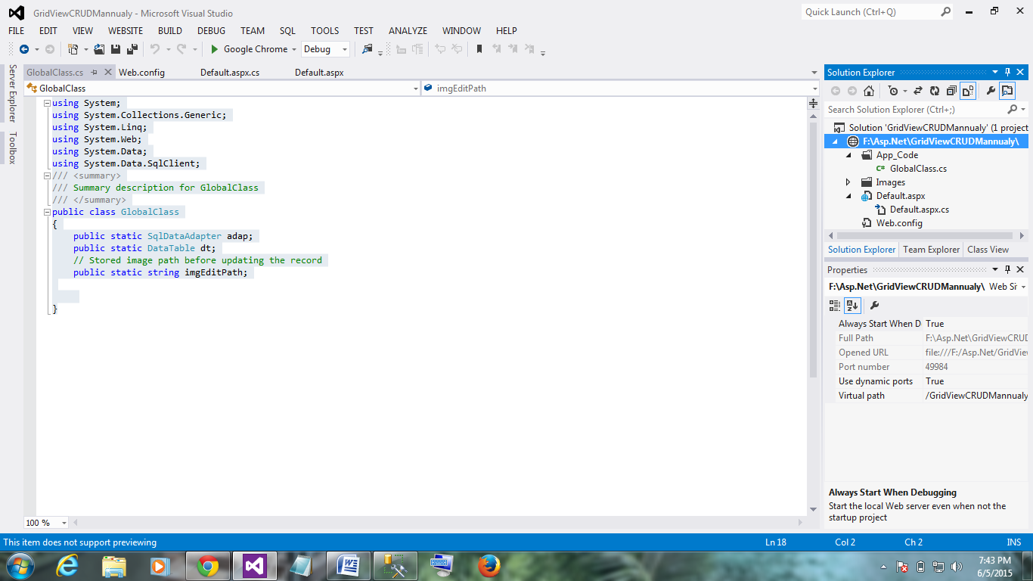

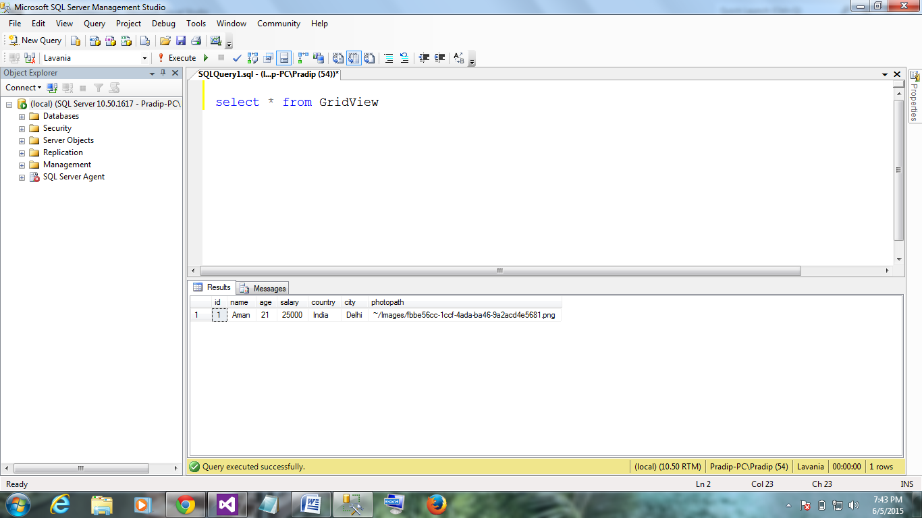

Table script

USE [Lavania]

GO

/****** Object: Table [dbo].[GridView] Script Date: 06/05/2015 19:44:24 ******/

SET ANSI_NULLS ON

GO

SET QUOTED_IDENTIFIER ON

GO

SET ANSI_PADDING ON

GO

CREATE TABLE [dbo].[GridView](

[id] [int] IDENTITY(1,1) NOT NULL,

[name] [varchar](50) NOT NULL,

[age] [int] NOT NULL,

[salary] [float] NOT NULL,

[country] [varchar](50) NOT NULL,

[city] [varchar](50) NOT NULL,

[photopath] [varchar](500) NULL,

PRIMARY KEY CLUSTERED

(

[id] ASC

)WITH (PAD_INDEX = OFF, STATISTICS_NORECOMPUTE = OFF, IGNORE_DUP_KEY = OFF, ALLOW_ROW_LOCKS = ON, ALLOW_PAGE_LOCKS = ON) ON [PRIMARY]

) ON [PRIMARY]

GO

SET ANSI_PADDING OFF

GO

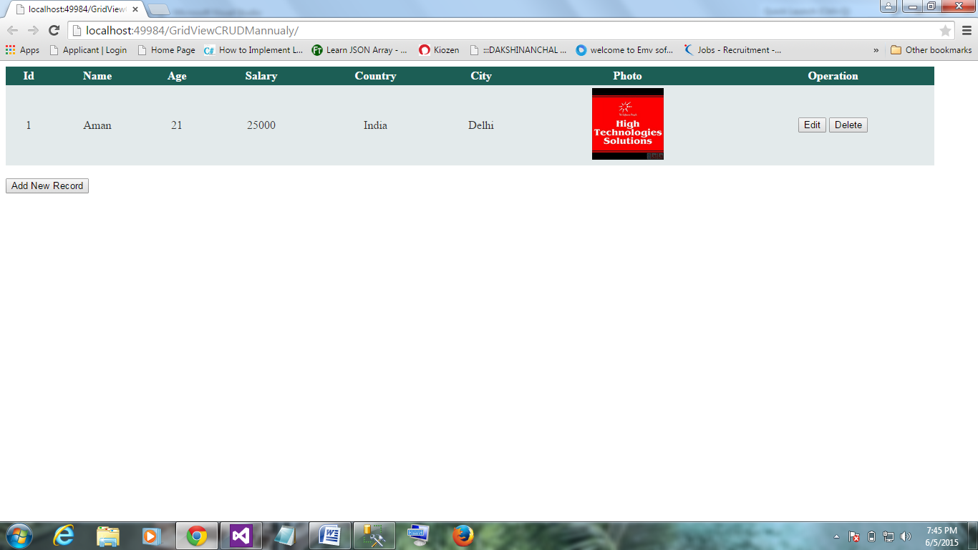

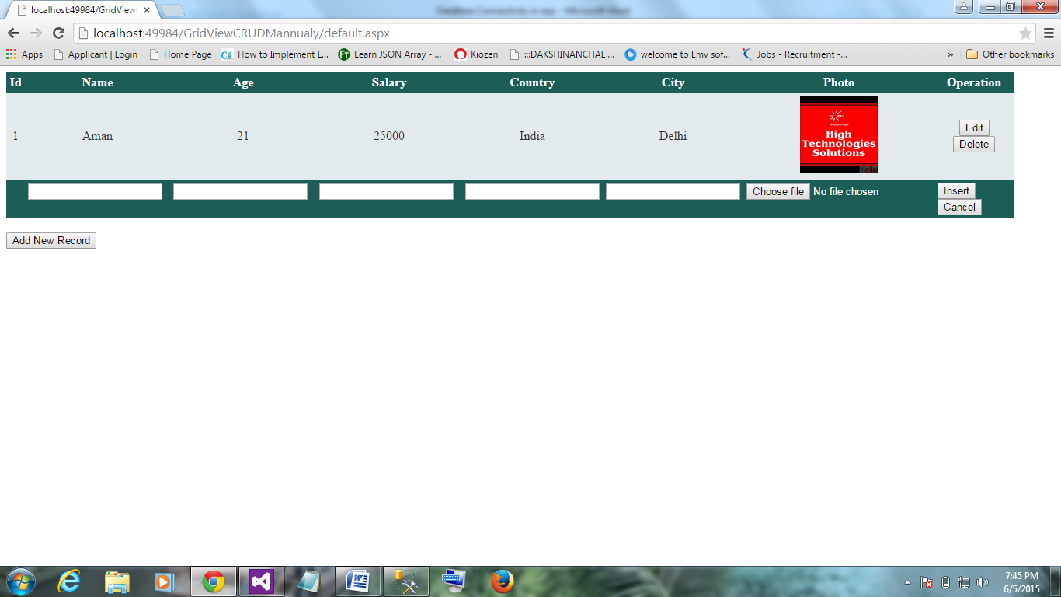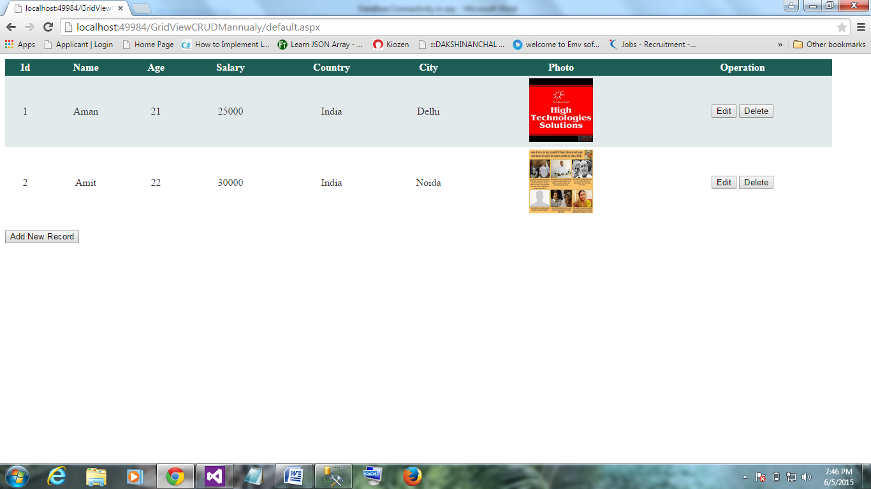

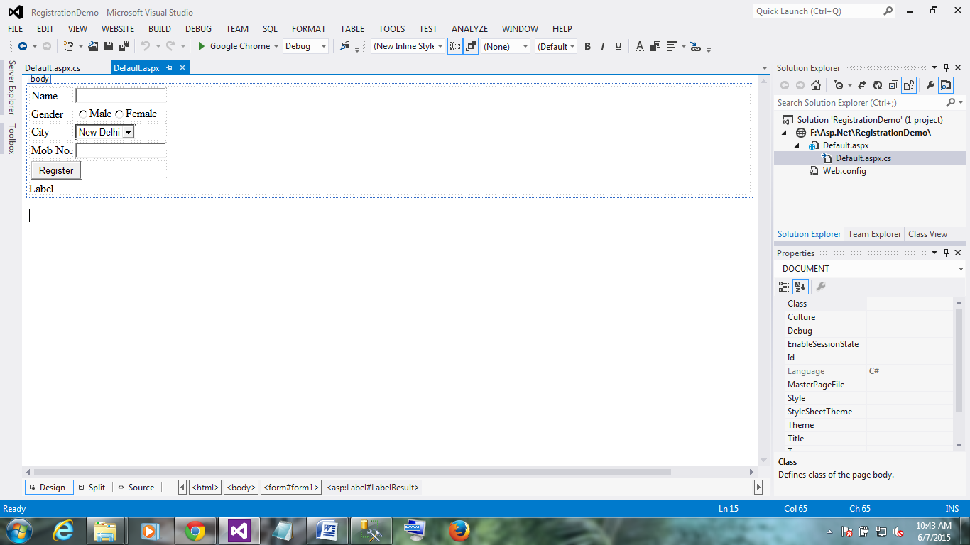

<%@ Page Language="C#" AutoEventWireup="true" CodeFile="Default.aspx.cs" Inherits="_Default" %>

<!DOCTYPE html>

<html xmlns="http://www.w3.org/1999/xhtml">

<head runat="server">

<title></title>

</head>

<body>

<form id="form1" runat="server">

<table>

<tr>

<td> <asp:Label ID="Label1" runat="server" Text="Name"></asp:Label></td>

<td> <asp:TextBox ID="TextName" runat="server"></asp:TextBox></td>

</tr>

<tr>

<td> <asp:Label ID="Label2" runat="server" Text="Gender"></asp:Label></td>

<td> <asp:RadioButton ID="RadioButton1" runat="server" Text="Male" /><asp:RadioButton ID="RadioButton2" runat="server" Text="Female" /></td>

</tr>

<tr>

<td> <asp:Label ID="Label3" runat="server" Text="City"></asp:Label></td>

<td> <asp:DropDownList ID="DropDownList1" runat="server">

<asp:ListItem>New Delhi</asp:ListItem>

<asp:ListItem>Noida</asp:ListItem>

<asp:ListItem>Mathura</asp:ListItem>

</asp:DropDownList></td>

</tr>

<tr>

<td> <asp:Label ID="Label4" runat="server" Text="Mob No."></asp:Label></td>

<td> <asp:TextBox ID="TextMob" runat="server"></asp:TextBox></td>

</tr>

<tr>

<td colspan="2">

<asp:Button ID="btnRegister" runat="server" Text="Register" OnClick="btnRegister_Click" /> </td>

</tr>

</table>

<asp:Label ID="LabelResult" runat="server" Text="Label"></asp:Label>

</form>

</body>

</html>

using System;

using System.Collections.Generic;

using System.Linq;

using System.Web;

using System.Web.UI;

using System.Web.UI.WebControls;

public partial class _Default : System.Web.UI.Page

{

string name, gender, city, mob;

protected void Page_Load(object sender, EventArgs e)

{

}

protected void btnRegister_Click(object sender, EventArgs e)

{

name = TextName.Text;

if (RadioButton1.Checked == true)

{

gender = RadioButton1.Text;

}

else if (RadioButton2.Checked == true)

{

gender = RadioButton2.Text;

}

else

{

gender = null;

}

city = DropDownList1.SelectedItem.ToString();

mob = TextMob.Text;

LabelResult.Text = "Your name is " + name + ",your gender is " + gender + ",your city is " + city + " and mob no is " + mob;

}

}

-